Getting Started with Databases

What is a database?

In simple terms, a database is a collection of data stored in a computer system. Here are other definitions of a database:  
   
According to **Wikipedia**:

A database is an organized collection of data, generally stored and accessed electronically from a computer system.

According to **Oracle**:

A database is an organized collection of structured information, or data, typically stored electronically in a computer system.

People use data and databases with or without awareness in their daily life activities.

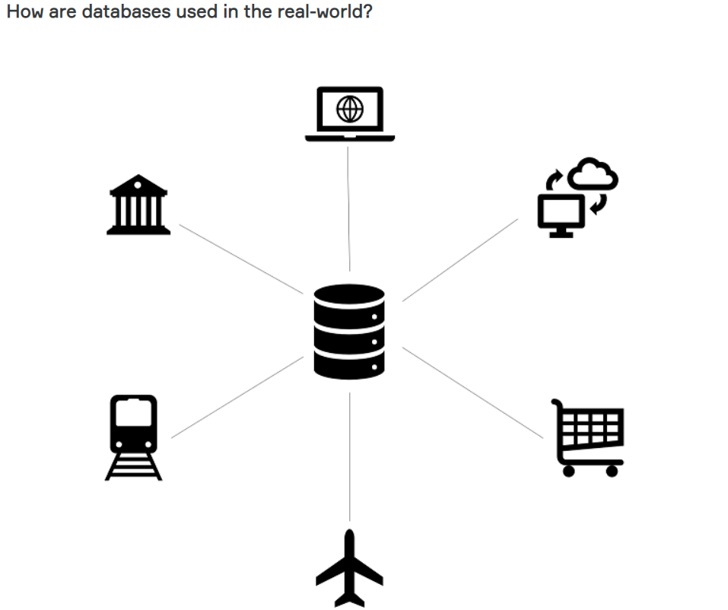

Databases are almost everywhere. Your bank, your grocery store, an app on your cellphone, websites all use databases to keep track of your data. When you access a website, the website starts to collect your data (e.g. accessing date and time, your location, your browser info) and store it in its database.

Let's take another example. When you order a product on a commercial website, your order is stored in a database. You withdrew money from your bank account. Your bank stores this transaction in the database. Social media platforms such as Facebook, Instagram, Twitter use databases to store data like members, their friends, member activities, messages, advertisements, etc.

(Note: In diagrams, databases are represented as a cylinder shape.)

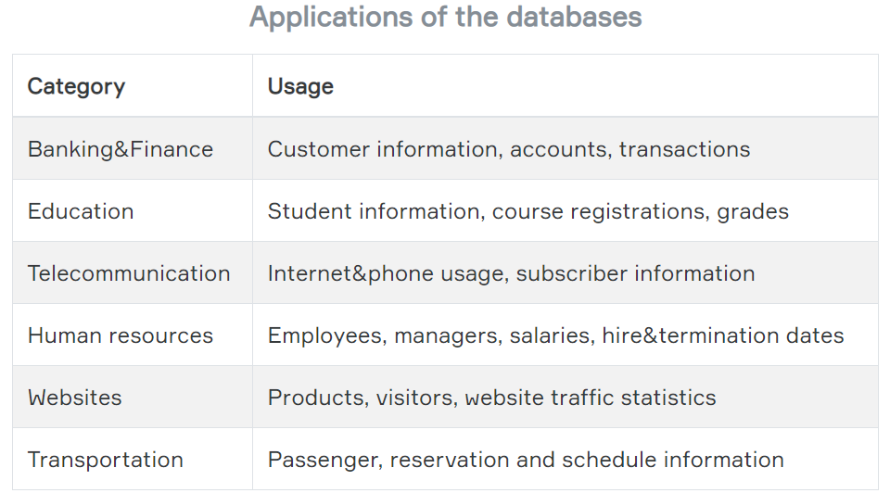

A database is typically controlled by a **database management system (DBMS)**. Data and DBMS along with the applications that are associated with them are called a database system, often shortened to just database.  
  
Now that we've learned what the database is, we can move on to what is inside the database, how the data is stored in the database.

Q: What is a Database?  
A: A database is an organized collection of data, generally stored and accessed electronically from a computer system. In simple terms, a database is a collection of data stored in a computer system. When you order a product on a commercial website, your order is stored in a database. You withdrew money from your bank account. Your bank stores this transaction in the database. Social media platforms such as Facebook, Instagram, Twitter use databases to store data like members, their friends, member activities, messages, advertisements, etc.

### What is in a database?

The information inside the database is grouped into tables. A table in a database is called a *database table*. Tables are the basic unit of data storage in databases. We talked about the definition of the database in the previous lesson. We used the term **structured data.**Structured data heremeans table. A table consists of columns and rows. You may think of it as an Excel or Google spreadsheet. Although there are similarities between the database table and Excel/Google spreadsheet, they are different things. We won't get into details here.

Veritabanındaki bilgiler tablolar halinde gruplanır. Veritabanındaki tabloya veritabanı tablosu denir. Tablolar, veritabanlarındaki temel veri depolama birimidir. Önceki derste veritabanının tanımından bahsettik. Yapısal veri terimini kullandık. Buradaki yapılandırılmış veriler tablo anlamına gelir. Bir tablo sütunlardan ve satırlardan oluşur. Bunu bir Excel veya Google e-tablosu olarak düşünebilirsiniz. Veritabanı tablosu ile Excel / Google e-tablosu arasında benzerlikler olsa da, bunlar farklı şeylerdir. Burada ayrıntılara girmeyeceğiz.

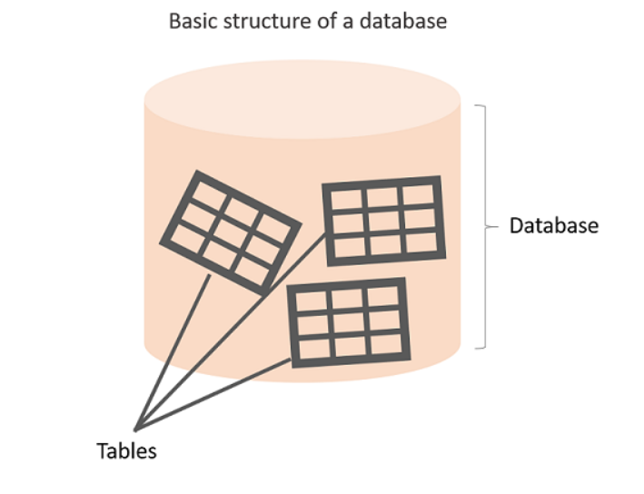

**Anatomy of a Table**

A table is made up of columns and rows. A column is a piece of data stored by the table. A row is a single set of columns that describe the attributes of a single thing. Columns should have a unique name. Columns and rows together make up a table.

**💡Tips:**

* In database world;
* A column is also called a field or attribute,
* A row is also called a record or a tuple,
* A table is also called a relation.

Column header names are written in lowercase, and there shouldn't be any space in a single name. Put an underscore between them. For instance, don't write "*last name"* as a header name, instead, write "*last_name"*. Table names are also written in lowercase and without space (*employees*, *customers*, etc.)

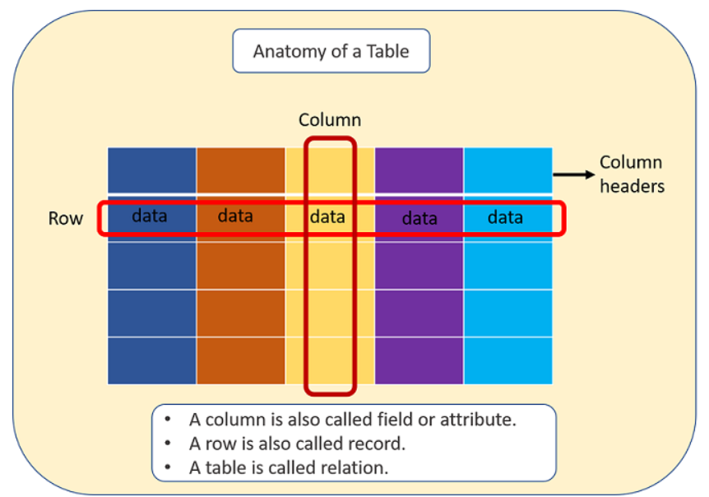

A database can consist of one or more tables. In most cases, more than one table. Each table has a unique name, such as employees, departments, or customers, etc.

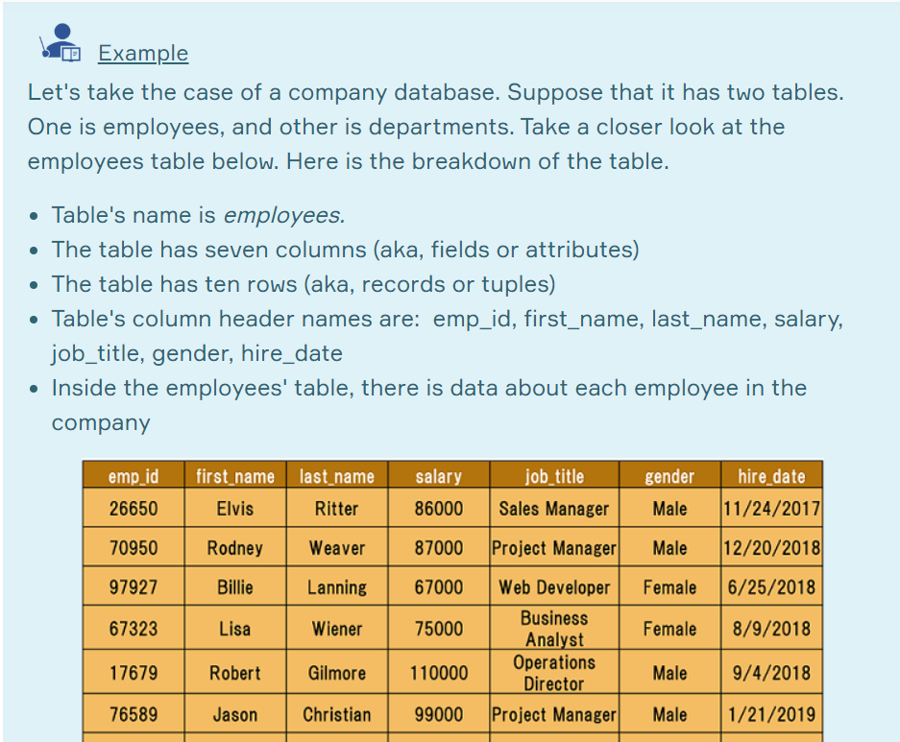

Of course, a real-world company would have many more employees. We use a small table to illustrate concepts.

Q: What is a table, column and row?  
A: A table is an organized collection of data stored in the form of columns and rows. Columns can be categorized as vertical and rows as horizontal. The columns in a table are called fields while the rows can be referred to as records.

Type of Databases

Typically, there are two main database storage types:

* **Relational Database - SQL**
* **Non-Relational Database - NoSQL**

A *relational database* is a type of database that stores and provides access to data points that are related to one another. Relational databases are based on the relational model, an intuitive, straightforward way of representing data in tables. In a relational database, each row in the table is a record with a unique ID called the *key*. The columns of the table hold attributes of the data, and each record usually has a value for each attribute, making it easy to establish the relationships among data points.

*Relational Database*, birbiriyle ilişkili veri noktalarını depolayan ve bunlara erişim sağlayan bir veritabanı türüdür. İlişkisel veritabanları, tablolardaki verileri temsil etmenin sezgisel, doğrudan bir yolu olan ilişkisel modele dayanır. İlişkisel bir veritabanında, tablodaki her satır, anahtar adı verilen benzersiz bir kimliğe sahip bir kayıttır. Tablonun sütunları verilerin özniteliklerini tutar ve her kaydın genellikle her öznitelik için bir değeri vardır, bu da veri noktaları arasındaki ilişkilerin kurulmasını kolaylaştırır.

Actually, the term "relational database" was invented by E. F. Codd at IBM in 1970. Codd introduced the term in his research paper "A Relational Model of Data for Large Shared Data Banks". In this paper and later papers, he defined what he meant by "relational". One well-known definition of what constitutes a relational database system is composed of Codd's 12 rules. However, no commercial implementations of the relational model conform to all of Codd's rules, so the term has gradually come to describe a broader class of database systems, which at a minimum:

Aslında, "ilişkisel veritabanı" terimi, E. F. Codd tarafından 1970 yılında IBM'de icat edilmiştir. Codd terimi, "Büyük Paylaşılan Veri Bankaları için İlişkisel Veri Modeli" adlı araştırma makalesinde tanıttı. Bu makalede ve daha sonraki gazetelerde ne demek istediğini "ilişkisel" olarak tanımladı. İlişkisel veritabanı sistemini neyin oluşturduğunun iyi bilinen bir tanımı Codd'un 12 kuralından oluşur. Bununla birlikte, ilişkisel modelin hiçbir ticari uygulaması, Codd'un tüm kurallarına uymaz, bu nedenle terim yavaş yavaş daha geniş bir veritabanı sistemleri sınıfını tanımlamaya başlamıştır;

* Present the data to the user as relations (a presentation in tabular form, i.e. as a *collection* of tables with each table consisting of a set of rows and columns);
* Verileri kullanıcıya ilişki olarak sunma (tablo biçiminde bir sunum, yani her bir tablo satır ve sütunlardan oluşan bir tablo koleksiyonu olarak);
* Provide relational operators to manipulate the data in tabular form.
* Verileri tablo biçiminde değiştirmek için ilişkisel işleçler sağlayın.

A software system used to maintain relational databases is called a *Relational Database Management System (RDBMS).*  Here are some examples of RDBMS:

* Amazon Aurora
* Amazon RDS
* Microsoft SQL Server
* Oracle Database
* MySQL
* IBM DB2
* Maria DB
* PostgreSQL
* SQLite

SQL (stands for Structured Query Language) is accepted as the standard Relational Database Management System (RDBMS) language. So we usually prefer to call Relational Database as SQL and Non-Relational database as NoSQL.

SQL (Yapısal Sorgu Dili anlamına gelir) standart Relational Database Management System (RDBMS) dili olarak kabul edilir. Bu nedenle genellikle İlişkisel Veritabanı'nı SQL ve İlişkisel Olmayan veritabanı olarak NoSQL olarak adlandırmayı tercih ederiz.

**💡Tips:**

* SQLite is a relational database management system contained in a C library. In contrast to many other database management systems, SQLite is not a client–server database engine. Rather, it is embedded into the end program. (Wikipedia)
* SQLite, C kütüphanesinde bulunan ilişkisel bir veritabanı yönetim sistemidir. Diğer birçok veritabanı yönetim sisteminin aksine, SQLite bir istemci-sunucu veritabanı motoru değildir. Aksine, son programa gömülüdür.

Structured Query Language (SQL)

SQL stands for Structured Query Language [and](http://ec2-35-173-203-107.compute-1.amazonaws.com/lms/mod/lesson/view.php?id=295) used to communicate with relational databases. SQL is a declarative language, not a procedural language. You write a single SQL declaration and hand it to the DBMS. The DBMS then executes internal code, which is hidden from us.

SQL, Yapılandırılmış Sorgu Dili anlamına gelir ve ilişkisel veritabanlarıyla iletişim kurmak için kullanılır. SQL, bildirimsel bir dildir, yordamsal bir dil değildir. Tek bir SQL bildirimi yazıp DBMS'ye teslim edersiniz. DBMS daha sonra bizden gizlenen dahili kodu yürütür.

**💡Tips:**

* Declarative paradigm is where you say what you want without having to say how to do it. With procedural paradigm (used in JAVA, C), you have to specify exact steps to get the result. SQL is declarative than procedural since the queries don't specify steps to produce the result.
* Açıklayıcı paradigma, nasıl yapılacağını söylemek zorunda kalmadan istediğinizi söylediğiniz yerdir. Prosedürel paradigma ile (JAVA, C'de kullanılır), sonucu elde etmek için kesin adımlar belirtmeniz gerekir. Sorgular sonucu üretmek için adımlar belirtmediğinden SQL yordamsaldan daha açıklayıcıdır.
* SQL in it's purest form is not a programming language, but a query language. Because, it needs to be able to perform loops and control structures. However, with some extensions, SQL can have looping and control structures but they exist outside or rather as an appendage to the original SQL spec. In this manner, some argue that SQL is a programming language.
* En saf haliyle SQL bir programlama dili değil, bir sorgu dilidir. Çünkü döngüleri ve kontrol yapılarını gerçekleştirebilmesi gerekir. Bununla birlikte, bazı uzantılarda, SQL döngüsel ve kontrol yapılarına sahip olabilir, ancak orijinal SQL spesifikasyonunun dışında veya daha ziyade bir ek olarak bulunurlar. Bu şekilde, bazıları SQL'in bir programlama dili olduğunu iddia eder.

Most commercial database systems employ the SQL language.With SQL, you can access or manipulate data stored in the database. There are different types of access. These are:

Çoğu ticari veritabanı sistemi SQL dilini kullanır. SQL ile veritabanında depolanan verilere erişebilir veya bunları değiştirebilirsiniz. Farklı erişim türleri vardır. Bunlar:

* Retrieval of data from the database - Veritabanından veri alınması
* Insertion of new data into the database - Veritabanına yeni verilerin eklenmesi
* Updating the data in the database - Veritabanındaki verileri güncelleme
* Deletion of data from the database - Veritabanından veri silinmesi

Besides, you can create new databases and tables using SQL.

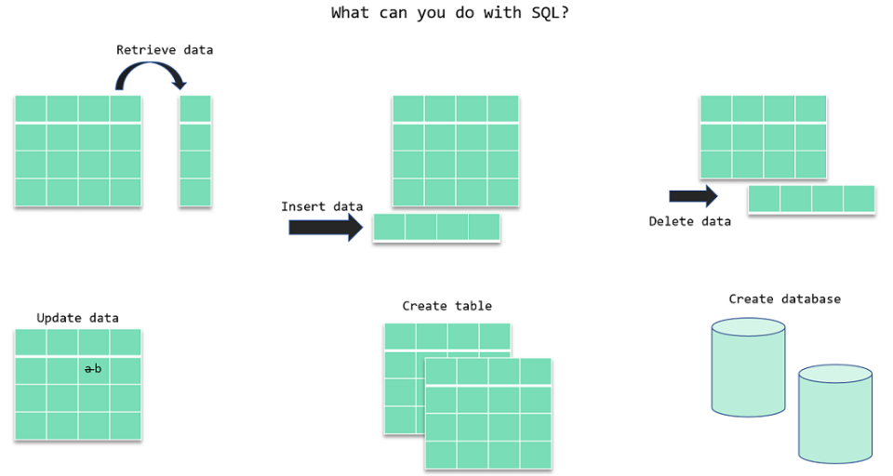

In the next section, we will focus on the retrieval portion of the SQL. There is a particular word that is called *query* for retrieval information from the database. You will often encounter this word during your SQL course journey.

ⓘ A **query** is a statement asking for the retrieval of information from the database.

ⓘ Query Sorgu, veritabanından bilgi alınmasını isteyen bir ifadedir.

Since SQL is a language, it has grammar. Now, let's learn how to write in that language.

Q: What is SQL?  
A: SQL stands for Structured Query Language and used to communicate with a database. With SQL, you can access or manipulate data stored in the database.

### SQL Language Elements

SQL language structure is easy to understand. It looks like plain English. Here is an example SQL statement:



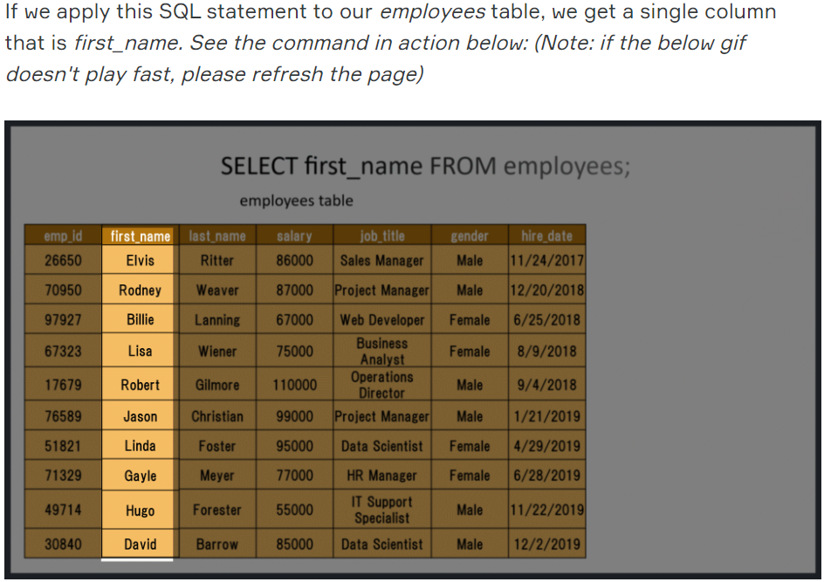

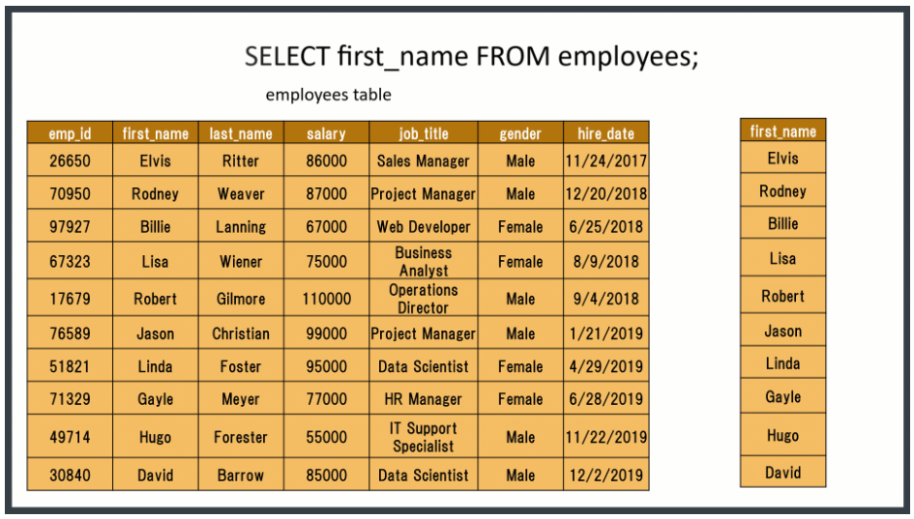

The whole command SELECT first_name FROM employees; is called **statement.**Let's breakdown of this statement. Herein SELECT, FROM words are keywords. They are special commands for SQL. first_name, employees are identifiers. SQL statements end with a semicolon (;).  SQL Language Elements is also called SQL Syntax.

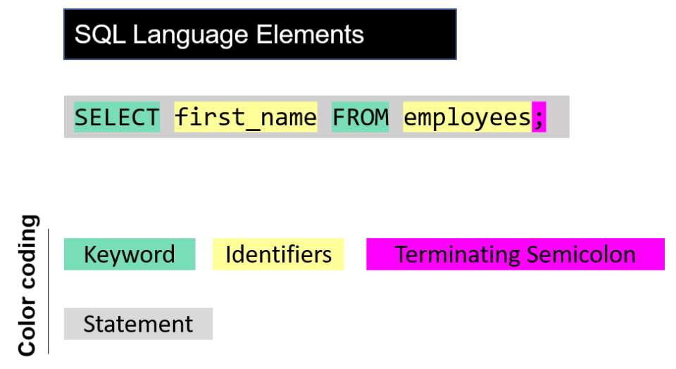

SELECT Statement

Introduction

In this lesson, you will focus on the SELECT statement in SQL. Generally;

* The SELECT statement is used to select data from a database.
* You can retrieve rows from the columns of the table by using this statement. Bu ifadeyi kullanarak tablonun sütunlarından satır alabilirsiniz.
* SELECT statement is used with FROM keyword.
* The syntax of the SELECT statement can be seen below.



By using this query, you explain to SQL that you want to see the data from a column/columns in the given table. The result of the query is stored in a result table called *result-set*.

Bu sorguyu kullanarak, SQL'e verilen tabloda bir sütun / sütunlardaki verileri görmek istediğinizi açıklarsınız. Sorgunun sonucu, sonuç kümesi adı verilen bir sonuç tablosunda saklanır.

### Basic Syntax

The term syntax in SQL refers to strict structural patterns used when creating a query. As in any other programming language, SQL also has some general syntax rules to follow. But these rules are very flexible compared with others. Let' look at the syntax of the last query again.

SQL'deki sözdizimi terimi, bir sorgu oluşturulurken kullanılan katı yapısal kalıpları ifade eder. Diğer tüm programlama dillerinde olduğu gibi SQL'in de takip etmesi gereken bazı genel sözdizimi kuralları vardır. Ancak bu kurallar diğerlerine göre çok esnektir. Son sorgunun sözdizimine tekrar bakalım.



As you see, SELECT and FROM words were written in uppercase, and the query ends with a semicolon. Is this usage example a syntax rule? In SQL syntax;

* SQL statements start with a keyword like SELECT, INSERT, UPDATE, DELETE, etc. and all the statements end with a semicolon (;).
* The semicolon at the end indicates that the statement is completed and ready to be executed.
* SQL is also case insensitive, which means you can use both SELECT and select in your query. They mean the same thing for SQL.
* Writing SQL commands in the upper-case is the most common and preferred style. But, you can write the same query in both ways as below:



* White spaces and empty lines are ignored in SQL. So, the below query is correct by all means.

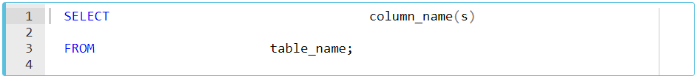

**💡 Tip:** To maintain your query clean and more readable, it's not recommended to use unnecessary empty lines and white spaces.

### Selecting Multiple Columns

### 

Assume that;

* You have a table named as **table1** like above.
* You want to see only column1 and column2 data in it.
* Then, you should write a query like this:

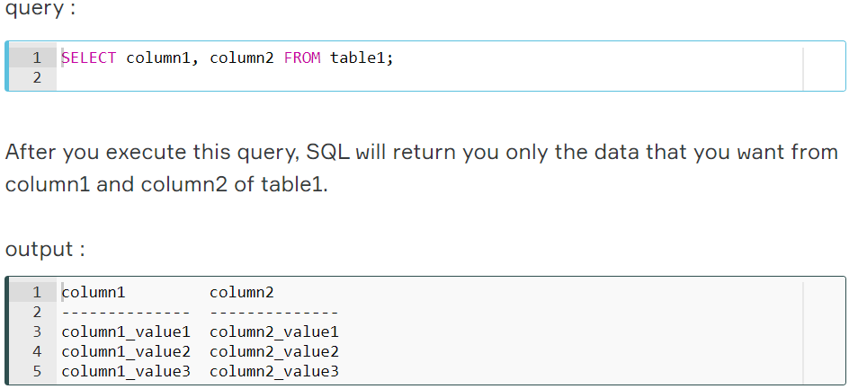

### Selecting All Columns

### 

Assume that; this time you want to see all of the data in your table.

You have 3 columns in your table, so you should write a query like this.

### 

### Because you wrote the names of all the columns in the SELECT statement, you will get the whole table via this query.

### 

### Selecting All Columns (Special Character)

The asterisk character “*” has special meaning in SQL.

To retrieve all of the information from your table, an asterisk (*) character can be used after the SELECT command.

So, you wouldn't have to type in each of the column names separately.

### 

## DISTINCT Clause

### Introduction

In this lesson, you will focus on the SELECT DISTINCT statement in SQL. Columns in the tables may often contain some duplicate values, but you may only need the distinct values as a result. Here comes the SELECT statement with the DISTINCT clause.

Bu derste, SQL'deki SELECT DISTINCT deyimine odaklanacaksınız. Tablolardaki sütunlar genellikle yinelenen değerler içerebilir, ancak bunun sonucunda yalnızca ayrı değerlere ihtiyacınız olabilir.

**ⓘ Info:** We have learned what the statement and keyword are. Here is another term which we introduced to you in this lesson: Clause. We want to define each three terms to help you gain better understanding. We will use query SELECT first_name, last_name, gender FROM employees; as an example to explain the concepts.

* **Keyword:**These are the individual elements which are predefined. In the example these are SELECT and FROM seperately.
* **Clause:**It's a part of a SQL statement. In our example, these ere SELECT first name, last name, gender and FROM employees.
* **Statement:**Thecomplete query is a statement. A statement may consist of two or more clauses.

### The SELECT DISTINCT is used to return only distinct (different/unique) values to eliminate duplicate rows in a result set. Here is the syntax of the DISTINCT clause:

### SELECT DISTINCT, sonuç kümesindeki yinelenen satırları ortadan kaldırmak için yalnızca farklı (farklı / benzersiz) değerler döndürmek için kullanılır. İşte DISTINCT deyiminin sözdizimi:

### 

### By using this query, you explain to SQL that you only want to see the unique/distinct data from the column/columns in the given table.

### Bu sorguyu kullanarak, SQL'e yalnızca verilen tablodaki sütun / sütunlardaki benzersiz / farklı verileri görmek istediğinizi açıklarsınız.

### No Duplicated Rows

### 

Assume that;

* You have a table named as *student_table* like above.
* You want to see only UNIQUE Values in student_column in the result set.
* Then, you should write a query like this.

### 

### As you see in the result set, the query returned all the rows in the student column. Because all the rows in that column have unique values. So, in this example, we can see that if there are no duplicated rows in a column, SELECT and SELECT DISTINCT gives the same result.

### Duplicated Rows

### 

### Let's write a different query to select unique lesson names from the lesson column. You should write a query like this.

### 

There are 7 rows in the student_table. But the result set has only 4 rows. Why?

* Lesson column consists of the following lessons; 3 Mathematics, 2 Physics, a Literature, and a Chemistry.
* So there are 3 duplicated rows of which 2 Mathematics and 1 Physics.
* DISTINCT clause eliminated 3 rows and so we get 4 unique rows.

WHERE & LIMIT Clauses

Introduction

In this lesson, you will focus on the WHERE clause in SQL. The WHERE clause is used to filter records.

* It allows you to define a specific search condition for the result set returned by a query. Bir sorgu tarafından döndürülen sonuç kümesi için belirli bir arama koşulu tanımlamanıza olanak tanır.
* So, the result set only consists of the records that fulfill the predefined condition(s). Dolayısıyla, sonuç kümesi yalnızca önceden tanımlanmış koşulları yerine getiren kayıtlardan oluşur.

The WHERE clause is mostly used with the SELECT statement. In addition to the SELECT statement, it may also be used with some other statements like DELETE and UPDATE. It's used in a query after the FROM clause as in the below example.



By using this query, you explain to SQL that you only want to get the data that pass the defined condition(s) as a result set.

### WHERE Clause - Operators

You can use the following operators in the WHERE clause.

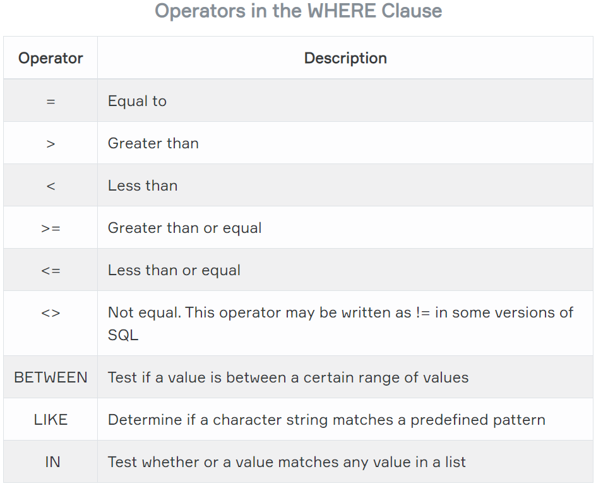

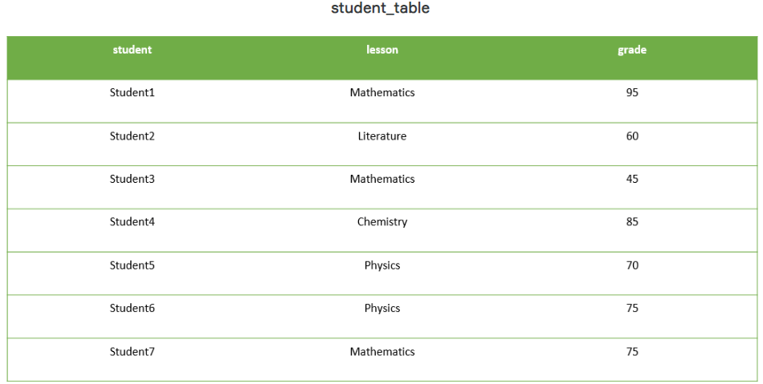

Assume that;

You have a table named student_table as above.

If we want to select only the records of which grade is higher than 70 in the result set, then we should write a query like this.

### 

### 

### 

### 

### 

### LIMIT Clause

In this lesson, you will focus on the LIMIT clause in SQL. The LIMIT clause is used to filter records. It constrains the number of rows returned by a query. Assume that your query returns one thousand rows. But you only want to see the first 10 rows in the result set. In such cases, we use LIMIT clause to obtain the desired output.   
  
Here is the syntax of the LIMIT clause.

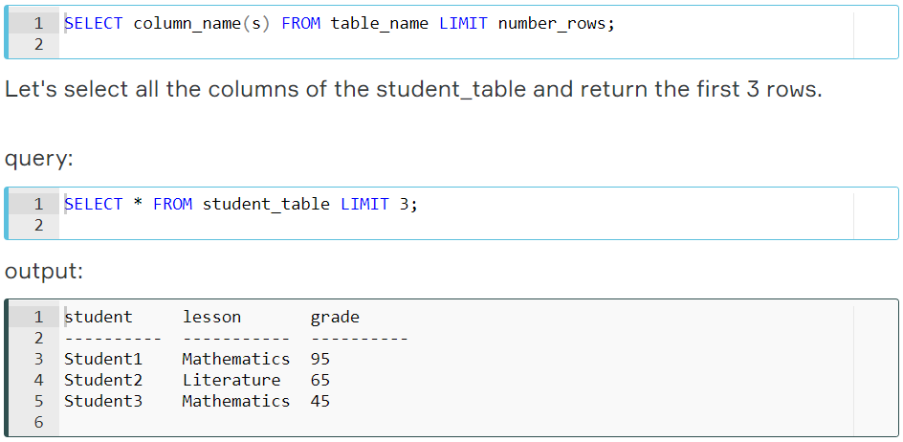

We can also combine LIMIT with WHERE. LIMIT clause is placed after the WHERE clause. Let's select the students whose grade is higher than 70 and let our query return the first 2 rows.

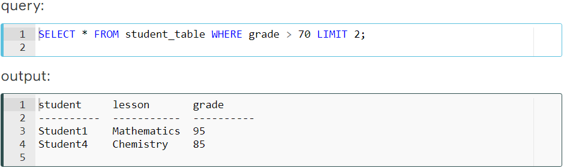

## ORDER BY Clause

### Order By Clause

SELECT statement returns records in an unspecified order. In case you want to retrieve data in alphabetical or numeric order, we use ORDER BY keyword. SELECT ifadesi kayıtları belirtilmemiş bir sırayla döndürür. Verileri alfabetik veya sayısal sırada almak istiyorsanız, ORDER BY anahtar sözcüğünü kullanırız.

The ORDER BY keyword sorts the result-set in descending or ascending order. ORDER BY anahtar sözcüğü, sonuç kümesini azalan veya artan sırada sıralar.

By default ORDER BY keyword sorts the records in ascending order. Use the keyword DESC to sort the records in descending order. You can also use ASC to sort the data in ascending order. You have to use either of them. Varsayılan olarak ORDER BY anahtar sözcüğü kayıtları artan sırada sıralar. Kayıtları azalan sırada sıralamak için DESC anahtar sözcüğünü kullanın. Verileri artan düzende sıralamak için ASC'yi de kullanabilirsiniz. İkisini de kullanmalısınız.

Here is the syntax of ORDER BY:



Herein **"|"** symbol means "use either ASC or DESC". If you don't use any of them, the default value is ASC (ascending order).  
Let's see ORDER BY in an action.

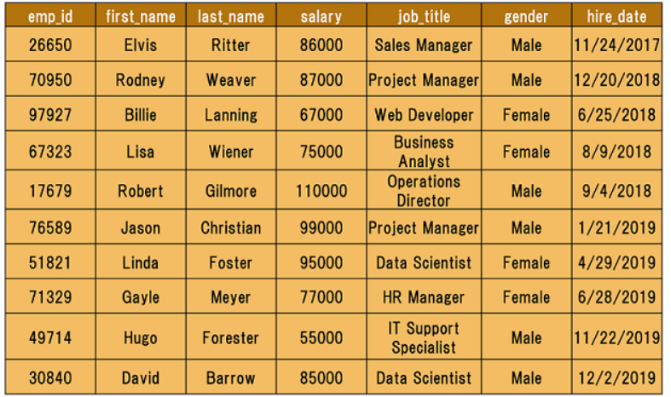

Here is our employees table. I want to sort the *first_name*column in alphabetical order (A-Z). This is the appropriate query:



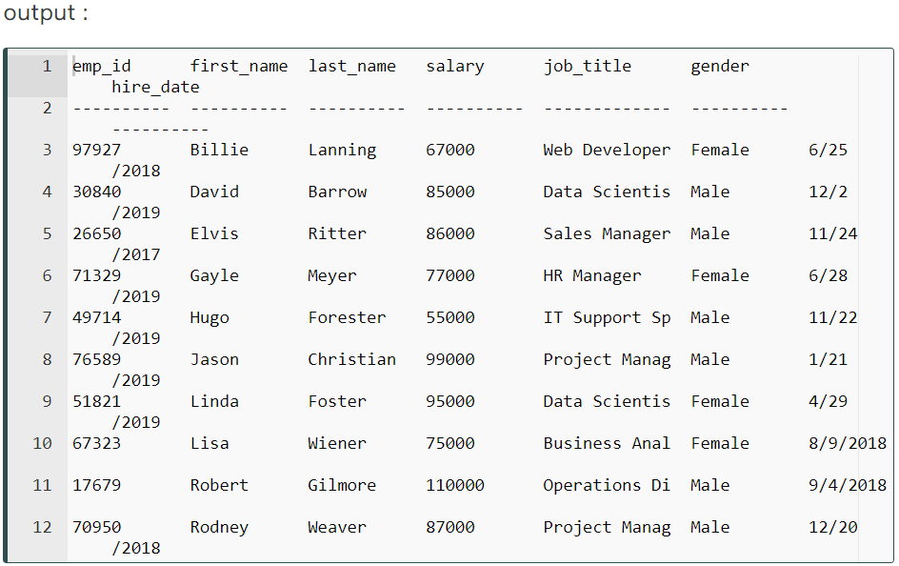

### Sorting in Descending Order

In the previous part, we sorted our table by the first names of the employees in ascending order. What if we asked you to sort it in descending order (Z-A)? You would probably say that "I use the **DESC** keyword." You're right. Let's write the query.

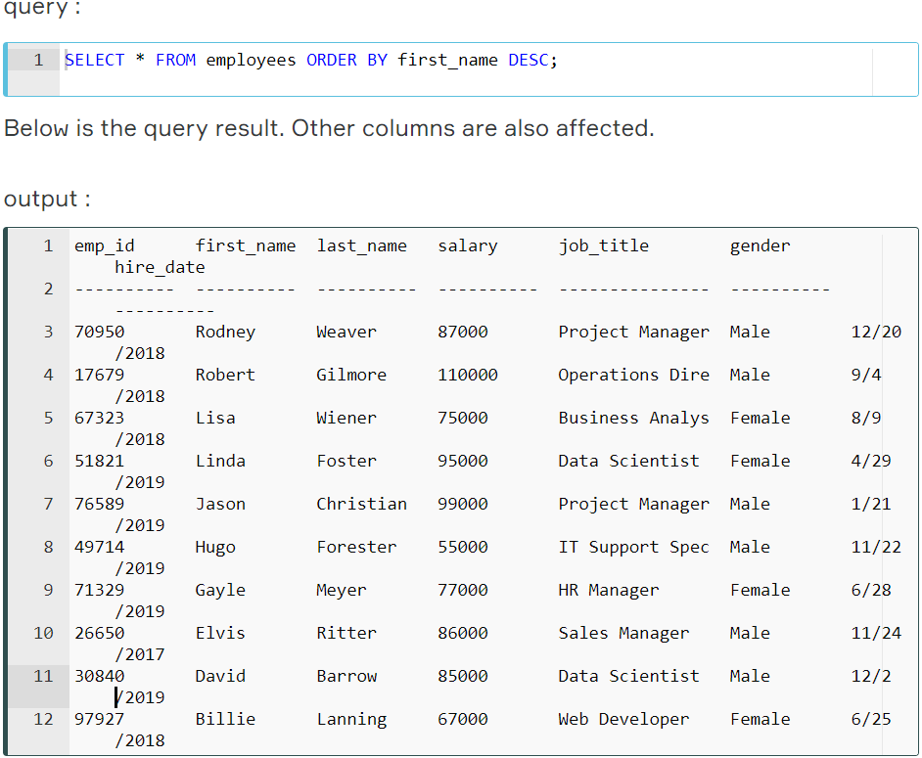

Until now, we've sorted the column containing textual data. It's time to sort numerical data in our table. You may wonder whose salary is the highest. Let's write the query. This time we don't want to retrieve all columns instead we want first name, last name and salary.

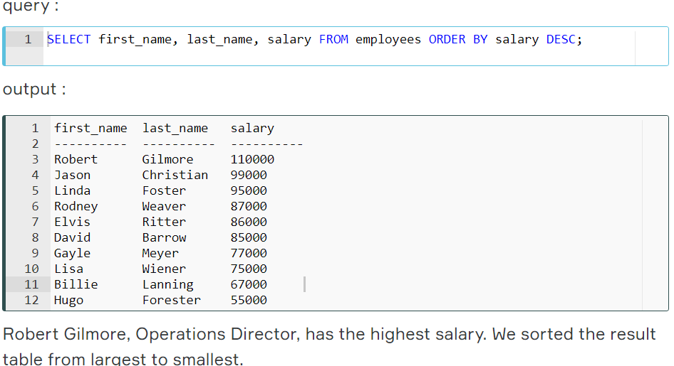

### Sorting By Multiple Columns

We are now able to sort by one column using the **ORDER BY**keyword. In some cases, we may need to sort our data by two columns or more. To do this, separate the columns by a comma. Here is the **syntax:**

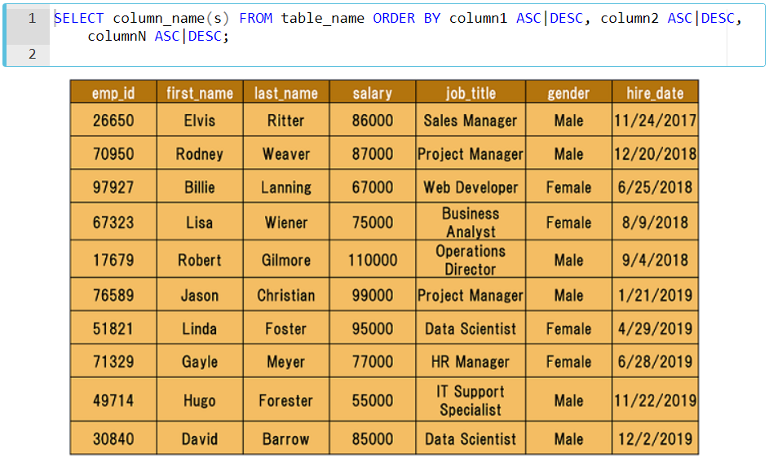

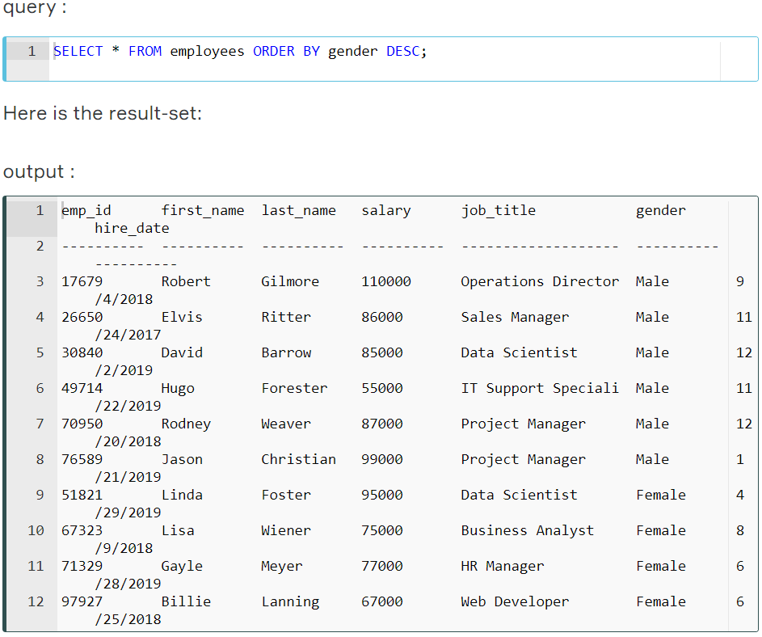

In the above output, you can see that the result table is sorted in descending order according to the gender of the employees. Suppose that we also want to sort it by first names.

In this case, we have to append the first_name column to our existing query. Use a comma to add the new column.

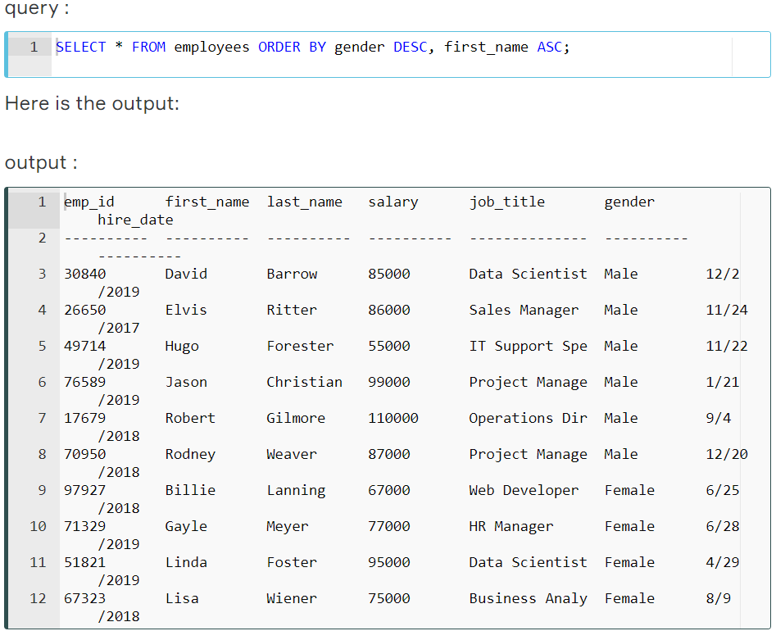

In the above example, we first sorted the data by gender, then we sorted by first names.

### ORDER BY Clause with WHERE Clause

In this part, we will use ORDER BY with the WHERE clause.

This is the syntax:



ORDER BY clause is placed after the WHERE clause.

Technically, any SQL statement can be written on a single line. However, it will become difficult to read when you start to write long queries. The solution in such cases is to organize the code, not just *horizontally*, but also *vertically*. This is called **beautifying.**Let's rewrite the syntax above.

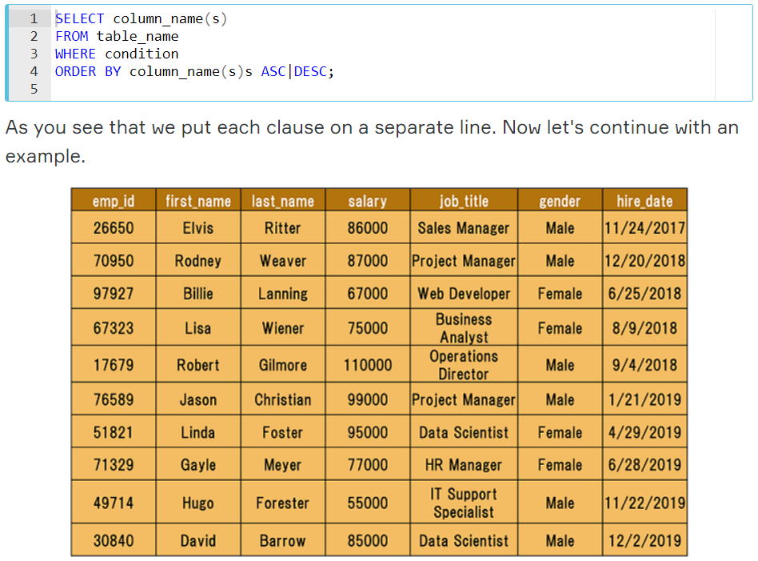

Assume that we try to find the employees whose salary is higher than $80,000. Next, we will sort it by first_name in descending order.

Here is the query:

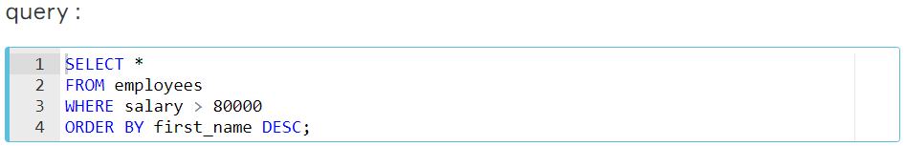

This is our result table:

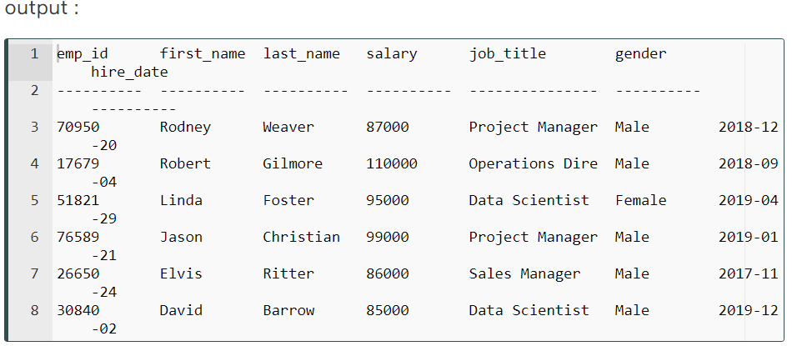

We first returned the employees whose salary is higher than $80,000. Next, we sorted this by the first names in descending order. Alright, we now know how to sort our table. It's time to put them into practice.

## AND, OR & NOT Operators

### Introduction

In SQL, **AND, OR & NOT** keywords are called operators. In particular, they are called logical operators. Their purposes are filtering the data based on conditions.

The WHERE clause can be combined with AND, OR & NOT operators. Let's start with the AND operator.

### AND Operator

The AND operator is used with the WHERE clause and combines multiple expressions. It returns only those records where both conditions (in WHERE clause) evaluate to True. The syntax has the following form in the WHERE condition:

AND işleci WHERE yan tümcesiyle birlikte kullanılır ve birden çok ifadeyi birleştirir. Yalnızca her iki koşulun (WHERE yan tümcesinde) True olarak değerlendirildiği kayıtları döndürür. Sözdizimi WHERE koşulunda aşağıdaki forma sahiptir:



Now, display the employees whose title is a data scientist and gender is male. You would be asked for the same thing as "show me the male data scientists in the company. " They are both the same.

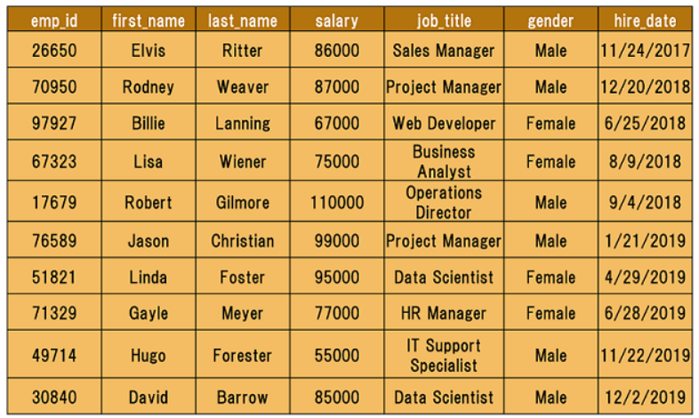

There are two conditions here. One is the title of the employee is a data scientist, other is the gender of his/her should be male. The correct search condition in where clause is job_title = 'data scientist' AND gender = 'Male'.

Let's write the query.

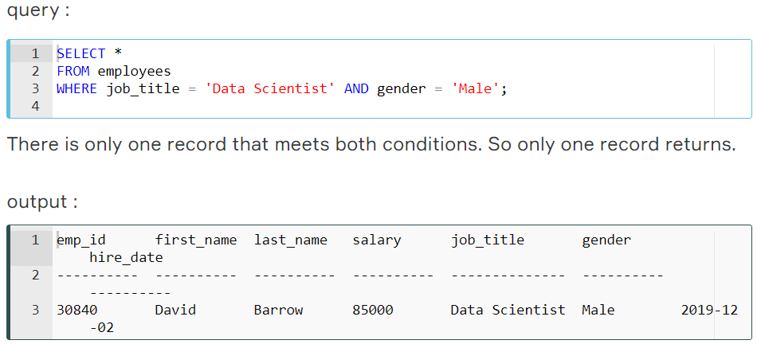

### OR Operator

The OR operator is used with the WHERE clause and combines multiple expressions. It displays the record where either one of conditions (in WHERE clause) evaluates to True. The syntax has the following form in the WHERE condition.

OR işleci WHERE deyimiyle kullanılır ve birden çok ifadeyi birleştirir. Koşullardan birinin (WHERE yan tümcesinde) True olarak değerlendirildiği kaydı görüntüler. Sözdizimi WHERE koşulunda aşağıdaki forma sahiptir.

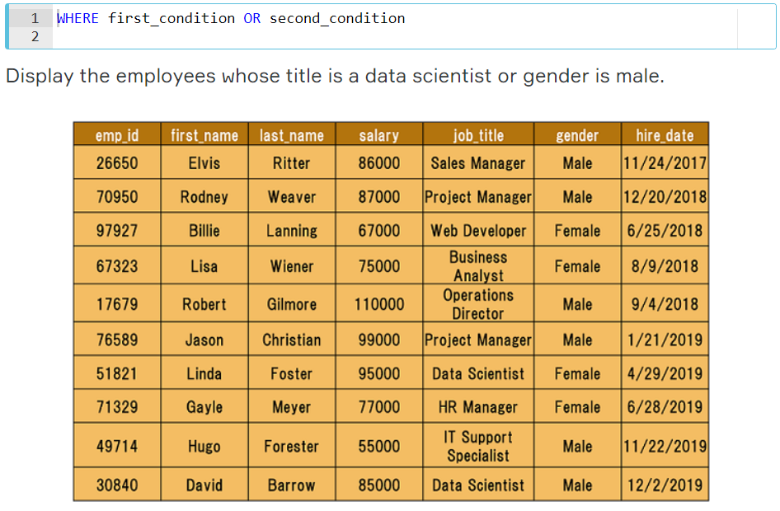

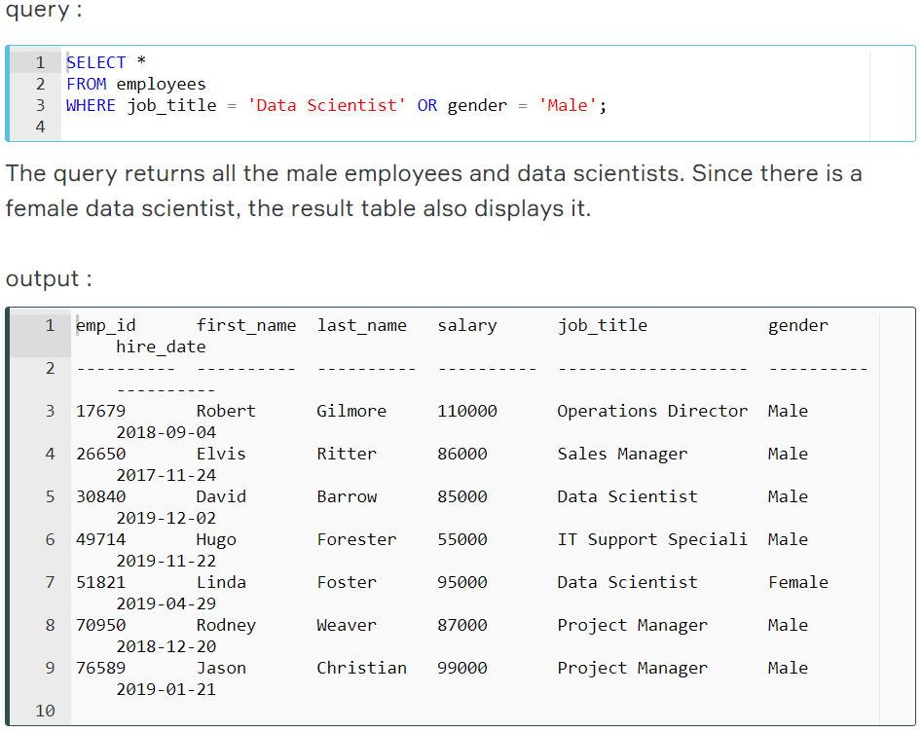

As we mentioned above, the records which meet either of the conditions return as a result. 

**💡 Tip:** Don't get confused with ANDs and ORs!

* When you want **ALL** of your conditions to be true, use **AND**
* When you want **ANY** of your conditions to be true, use **OR**

### NOT Operator

The NOT operator is used to negate a condition in the WHERE clause. NOT is placed right after WHERE keyword. You can use it with AND & OR operators. Here is the syntax of NOT operator.

NOT operatörü, WHERE yan tümcesindeki bir koşulu reddetmek için kullanılır. NOT, NEREDE anahtar sözcüğünden hemen sonra yerleştirilir. AND & OR operatörleriyle kullanabilirsiniz. İşte NOT operatörünün sözdizimi.



Display the male employees.

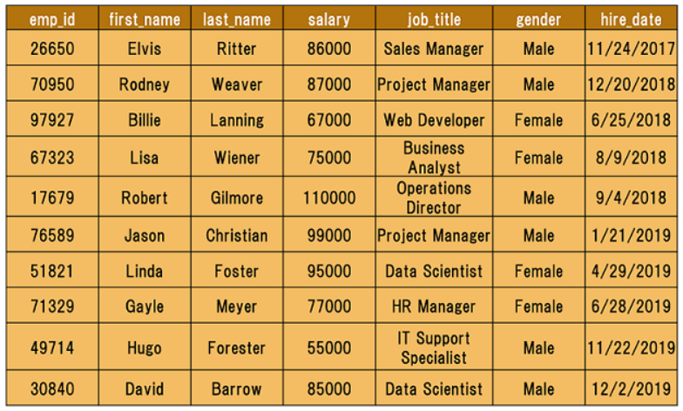

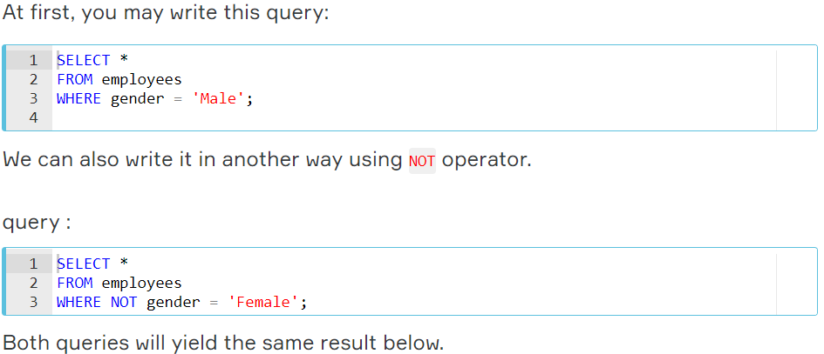

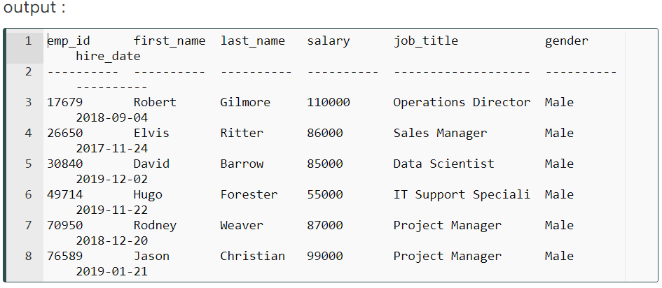

## BETWEEN OPERATOR

### Introduction

The BETWEEN operator is used for comparison in WHERE clauses. It's a comparison operator. You can use it to test if a value is in a range of values. If the value is in the specified range, the query returns all records fallen within that range.

BETWEEN operatörü WHERE yan tümcelerinde karşılaştırma yapmak için kullanılır. Bu bir karşılaştırma operatörü. Bir değerin bir değer aralığında olup olmadığını test etmek için kullanabilirsiniz. Değer belirtilen aralıktaysa, sorgu bu aralığa düşen tüm kayıtları döndürür.

The following displays the syntax of the BETWEEN operator:



Note that the BETWEEN operator is inclusive. The above syntax can be written as follows:



**☝ Important:** The **BETWEEN** operator is inclusive. To specify an exclusive range, use the greater than (>) and less than operators (<).

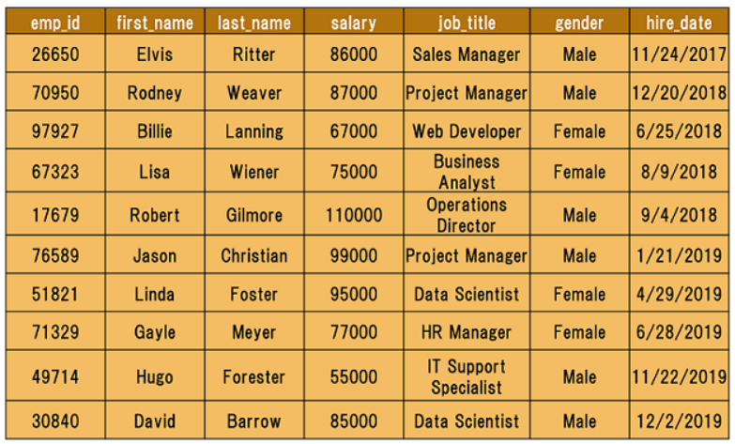

If we need to find the names of the employees with salary amounts between $80,000 and $90,000, we can use the BETWEEN comparison operator to write:

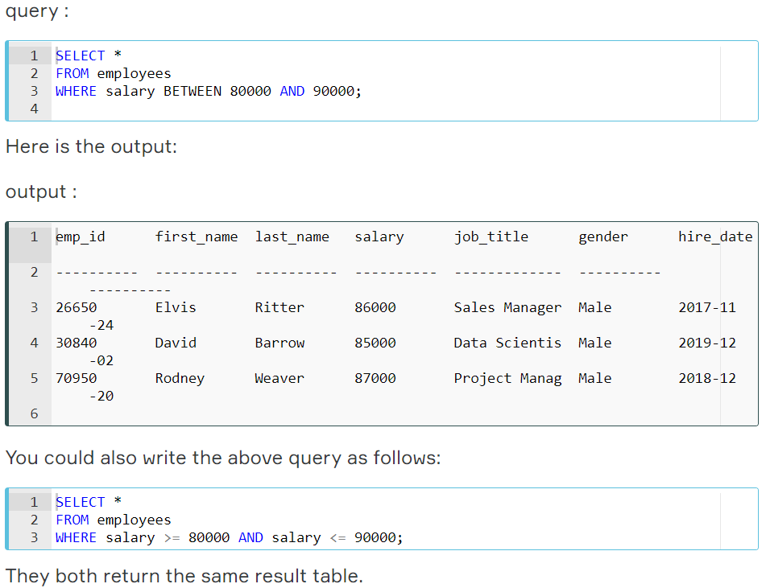

### NOT BETWEEN

We can use NOT BETWEEN to negate the result of the BETWEEN operator. The following is the syntax:



For instance, you need to find the employees whose salary is not between $80,000 and $90,000. Here is the query:

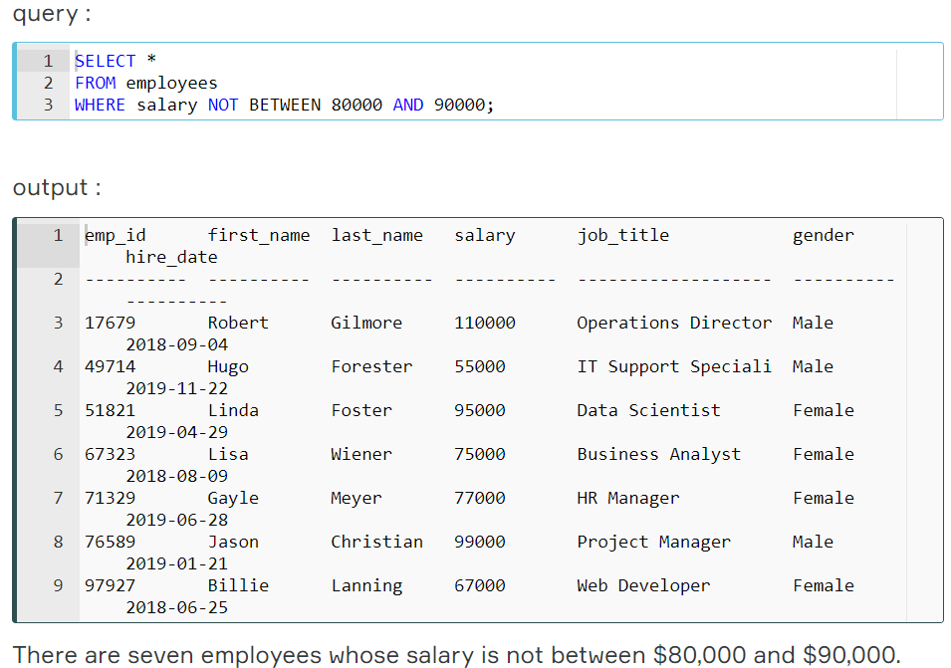

### BETWEEN with Date Example

It's also possible to use the BETWEEN operator with dates.

Assume that we try to find employees who have joined the company from June 1, 2018 to March 31, 2019. We also want to sort by hire date in ascending order.

**☝ Important:** Please enclose your date values with single quote (') and use YYYY-MM-DD date format in your query.

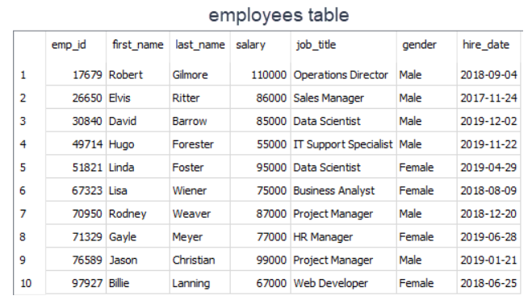

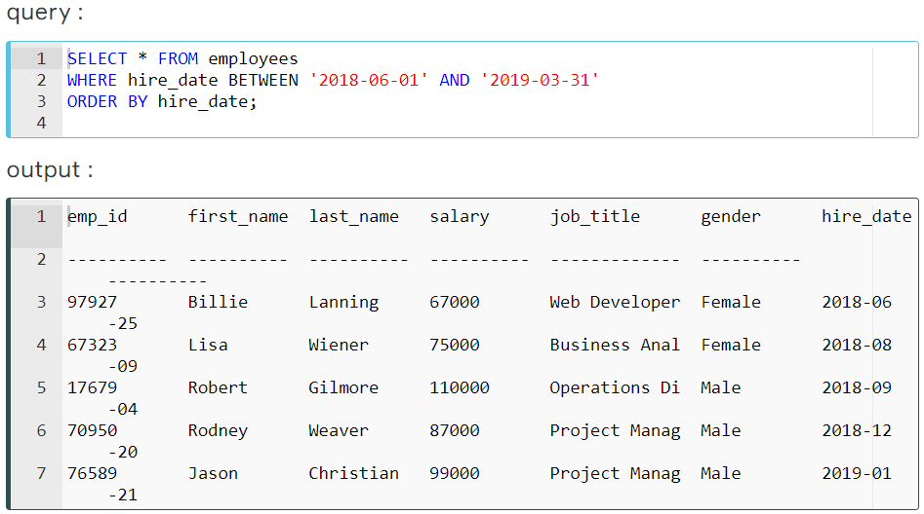

## IN Operator

### Introduction

The IN operator is used to determine whether a value matches any value in a list. We use IN operator with WHERE clause. Following is the syntax of the IN operator:



Suppose that you are building a team in your company. The team is comprised of Data Scientist and Business Analyst. You need to search the employee table to find the right candidates for your team. You may come up with this query:

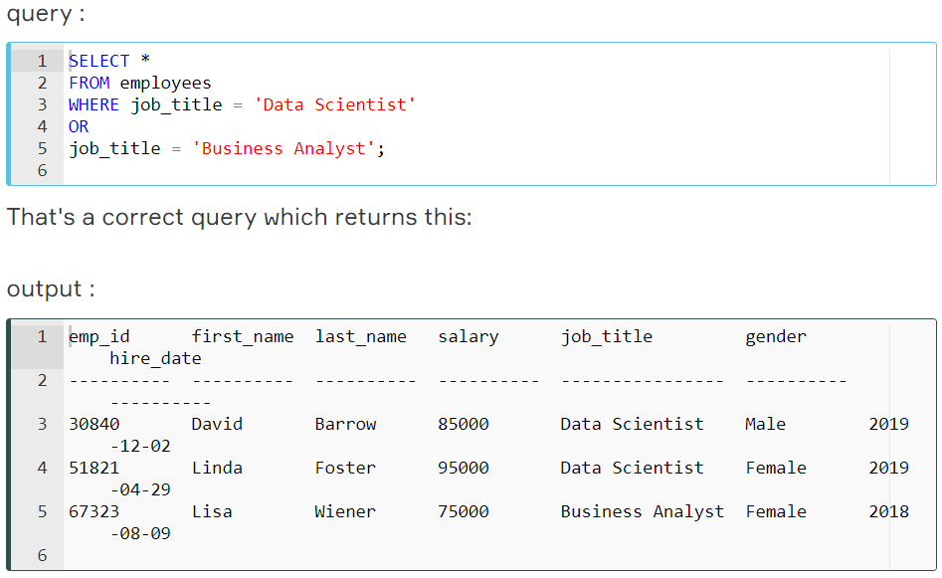

Three people meet your criteria.

However, there is a better operator in case you try to match a value in a specified list. We may rewrite the query as follows:

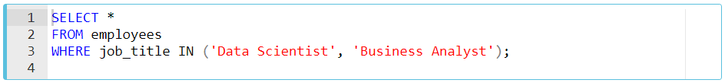

The query retrieves the employees whose job title is Data Scientist or Business Analyst. Herein the value list is ('Data Scientist', 'Business Analyst'). When any value in the job title column matches one of the values in the list, the related row is returned.

### An Extended Value List

Suppose that you have decided to add teammates to your existing team. In addition to data scientist and business analyst, you are in need of a project manager and web developer. You modified the old query in which you used the OR operator.

Here is the new query:

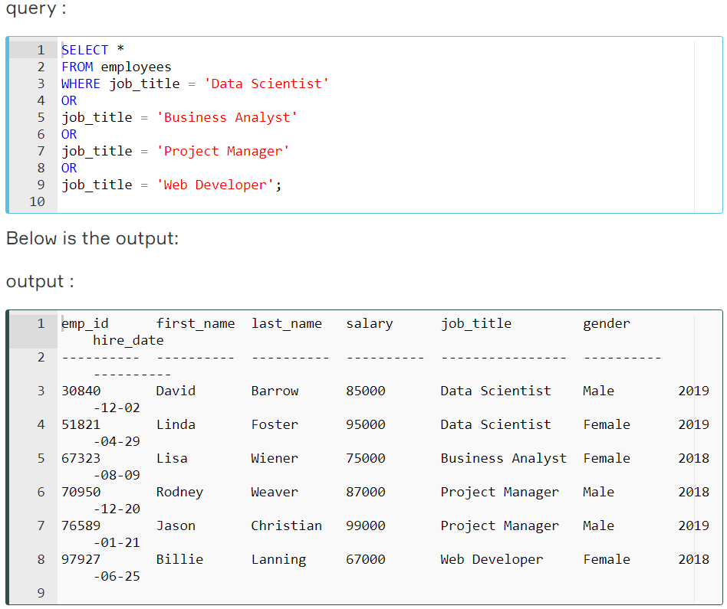

Then you thought that it's a better idea to use IN operator and revised the query using IN operator as below:

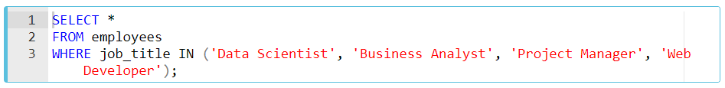

This query also returns the same result table. Six people meet your criteria.  
As you can see that using the IN operator makes your code shorter.

**💡 Tip:** If you have a query in which you use many OR operators, consider using the IN operator instead. This will make your query more readable.

### NOT IN Operator

In this part, we are going to add the keyword NOT to our IN operator.  You're building a team again. This time you decided to select the right candidates in a different way. You don't want to include Operations Director, HR Manager, and Sales Manager in the team.

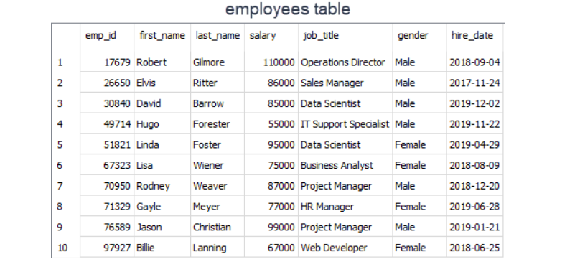

If we know which values we don't want to include in a list, we can use NOTkeyword with IN. NOT gives you the opposite results, anything that doesn't match the list. Use NOT just before IN operator.  
Let's write the query:

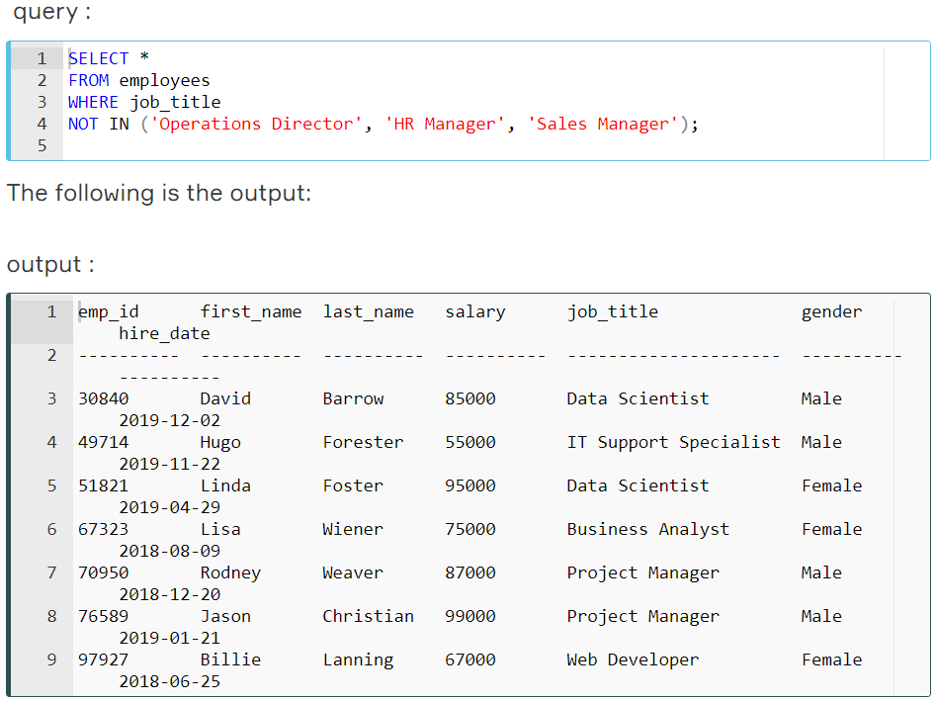

There are seven employees whose job title is not in the Operations Director, HR Manager, Sales Manager list. Alright, we completed the IN operator.

## LIKE Operator

### Introduction

There are some cases where you don't know exactly the complete value you query. For instance, consider that you're trying to recall a student's county info from our student_info table. You know that the county's name starts with 'Wo'. In such cases, we use LIKE operator.  We combine LIKE operator with WHERE clause.

The general syntax is:

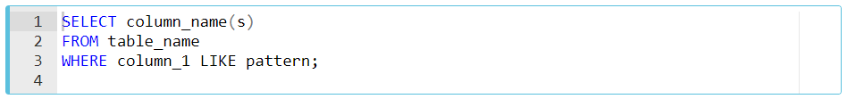

After LIKE keyword, we construct a pattern. SQL provides two special characters for constructing patterns. These are also called wildcards.

* **Percent (%):**The % character matches any sequence of zero or more characters.
* **Underscore ( _ ):** The _ character matches any single character.

Patterns are case insensitive. Uppercase characters do match lowercase characters or vice versa. Let's show pattern matching in the following examples. You will find some pattern examples which can be used after the LIKE operator. Patterns are written in single quotes.

* 'Out%' pattern matches any string beginning with "Out" such as "Outro".
* 's%' pattern matches any string that starts with "s" such as "silk", "soup", etc.
* '%per%' pattern matches any string containing "per" such as "percentile" and "peeper".
* 's_n' pattern matches "son", "sun", etc.
* '__te' pattern matches "mate", "Kate", "kate", etc.

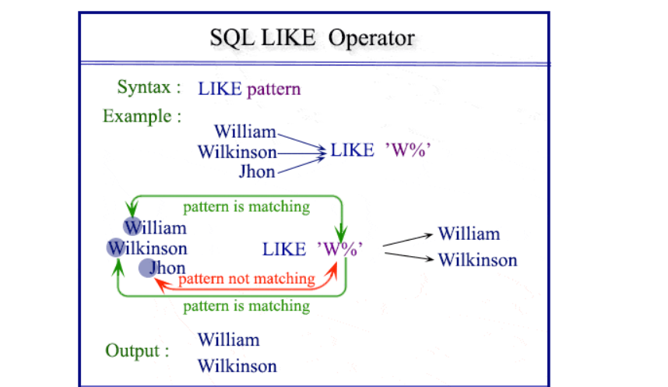

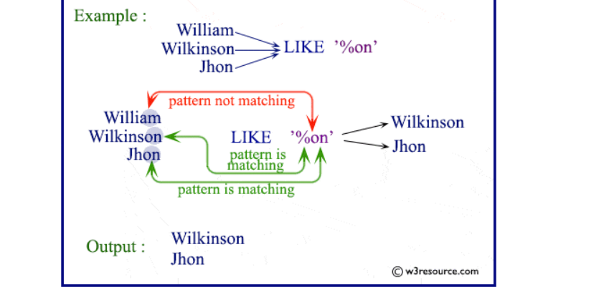

Now. Let's try to find a solution to our question at the beginning. We were trying to recall the county name which starts with "Wo". Since we don't know how many letters coming after "Wo", it's a good idea to use % wildcard here. Here is the pattern 'Wo%'.

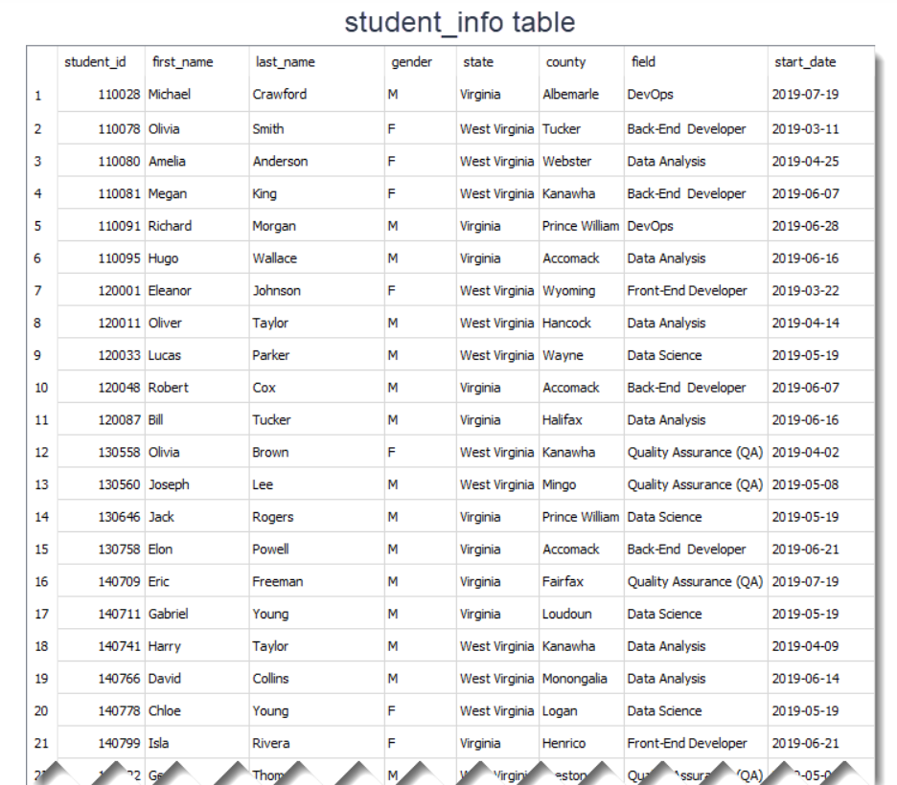

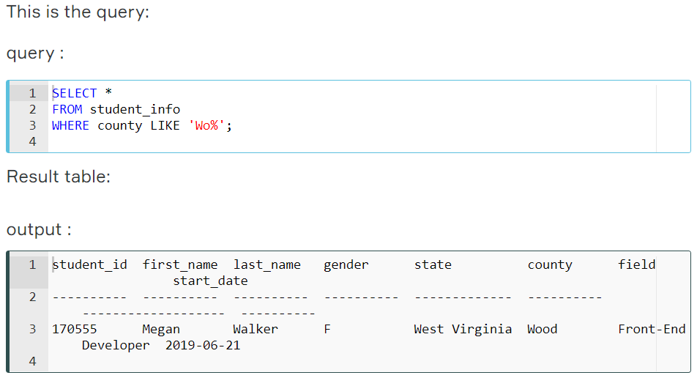

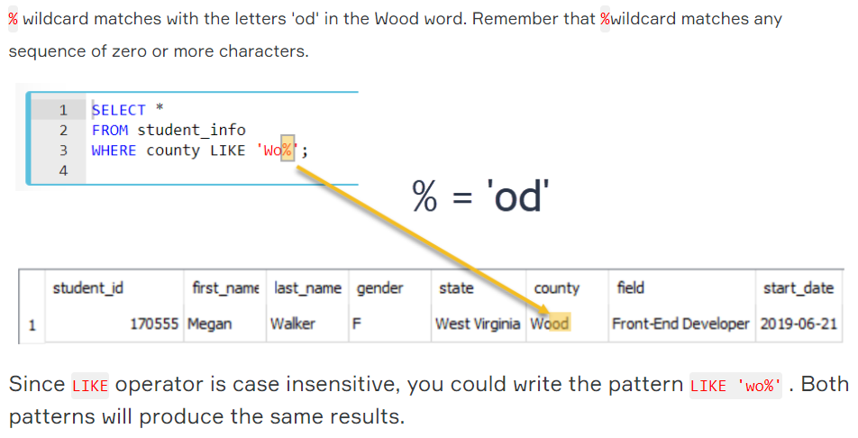

### Percent Character Example

In this part, we continue with another example using % wildcard.

Suppose that we try to find front-end and back-end developers in our student_info table. If we look at the **field** **column,**we see that the word "Developer" is found at the end of the each field value. So, what do you think the pattern will be?

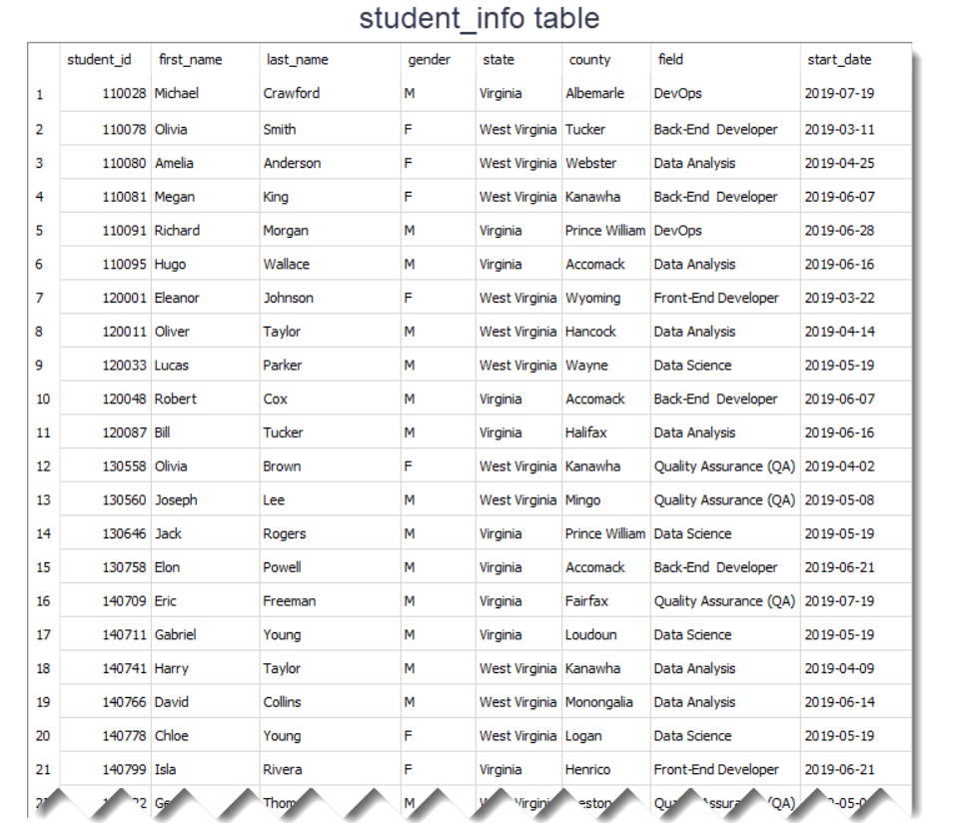

The pattern is '%Developer'. Herein % wildcard will include all the characters before the word "Developer". Let's write the query:

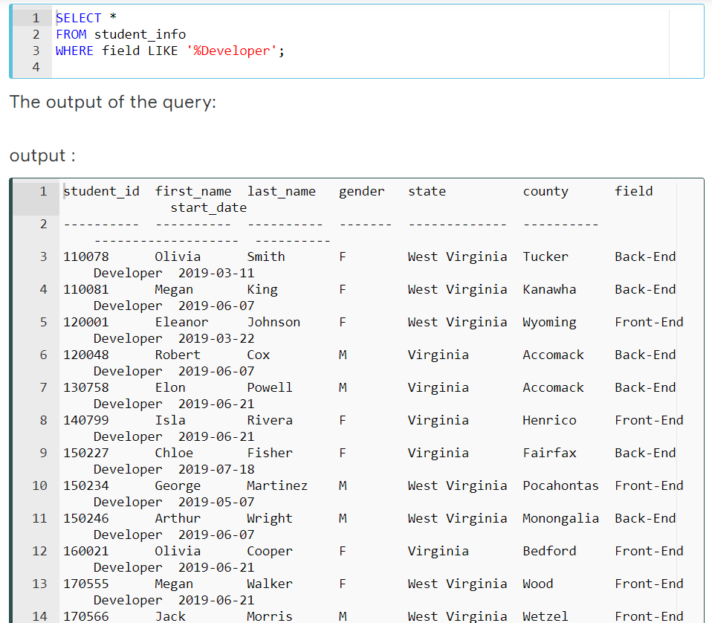

There are 12 students whose field is Back-End Developer or Front-End Developer. We could write the pattern as '%Developer%'. This also returns the same result table. There is no character coming after the word "Developer". But remember % wildcard also matches zero characters.

In the previous part, we said that LIKE operator is case-insensitive. That means instead of '%Developer', we can write '%developer', '%DEVELOPER' even '%DEveloper'. All those patterns will match "Back-End Developer" or "Front-End Developer".

However, if you want to make LIKE operator case-sensitive, we need to use PRAGMA statement as follows:



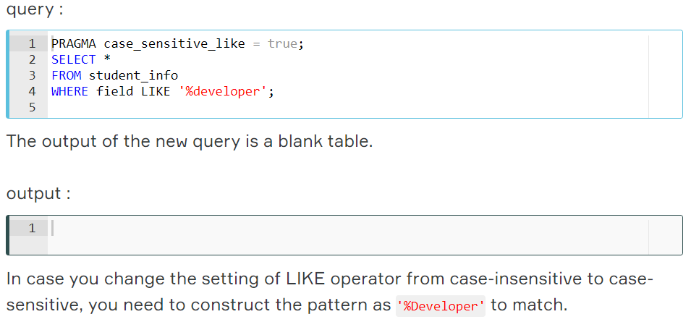

### Underscore Character Example

The underscore _ wildcard matches a single character. Think of it as representing a single character. For instance, the following query finds the employee whose first_name is "Elvis".

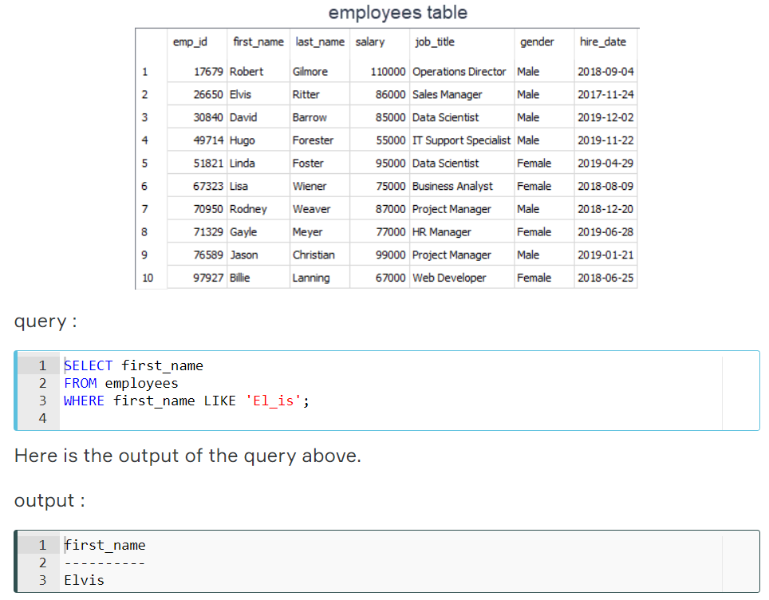

The _ wildcard in the pattern matches "v" letter in "El**v**is" in the first name column.

Which first name the 'Li__a' pattern will match in the first name column? The answer is "Linda". Note that there are two underscore characters in the 'Li__a' pattern. Thus, those will match "nd" letters in "Li**nd**a" in the first name column.

COUNT

What is an aggregate function?

In this section, we will introduce you to *aggregate functions*. Aggregate functions are functions that take a collection of values as input and return a single value. SQL has five built-in aggregate functions:

* COUNT (Count)
* MIN (Minimum)
* MAX (Maximum)
* SUM (Total)
* AVG (Average)

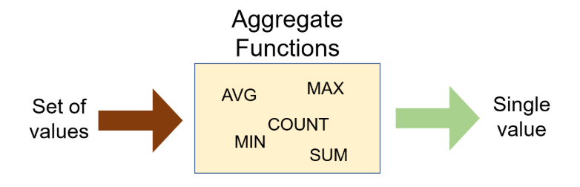

SUM and AVG functions must take only numeric values as input. However, the other functions (MIN, MAX, COUNT) may take non-numeric values (strings, date, etc.) as input other than numeric values. Before we dive into the aggregate functions, we should learn an important concept which is NULL.

NULL means no data and is a special value. It shows us that a piece of information is unknown or missing or not applicable. For instance, let's assume that we have a song database and we don't know the writers of some of them. We don't have that information. So, to store these unknown songwriters in a database table, we must use NULL. If a table has NULL value, then it will be displayed as NULL.

**💡Tips:**

* NULL value represents the unknown value or missing value or not applicable.
* NULL is not equal to zero or empty string.
* NULL is not equal to itself.

It's important to understand what nulls mean and to know how to work with them. They are often ignored in our aggregation functions.

Alright, let's start with COUNT function.

Q: What is an aggregate function?  
A: An aggregate function performs operations on a collection of values to return a single scalar value. Aggregate functions are often used with the GROUP BY and HAVING clauses of the SELECT statement.

## COUNT

### Introduction

We use COUNT function to count the numbers of records (a.k.a row) in a table. Here is the syntax of the COUNT function:



Use COUNT keyword immediately after SELECT keyword. Then specify the column on which you want to operate.   
Suppose that we want to count how many students enrolled in the courses.

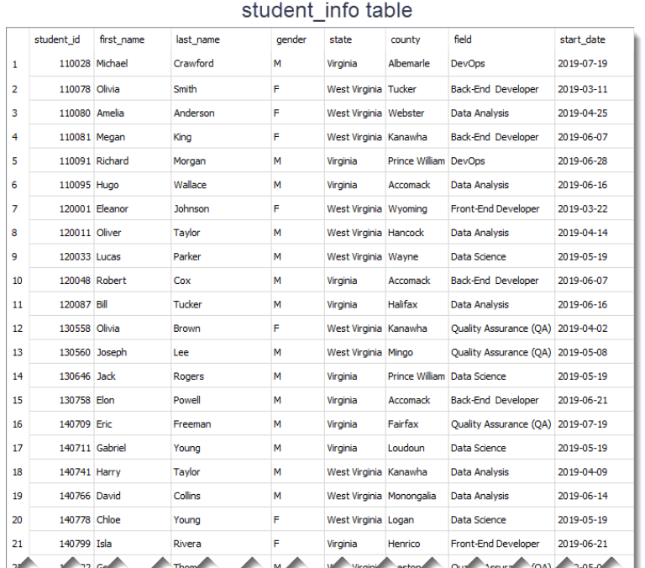

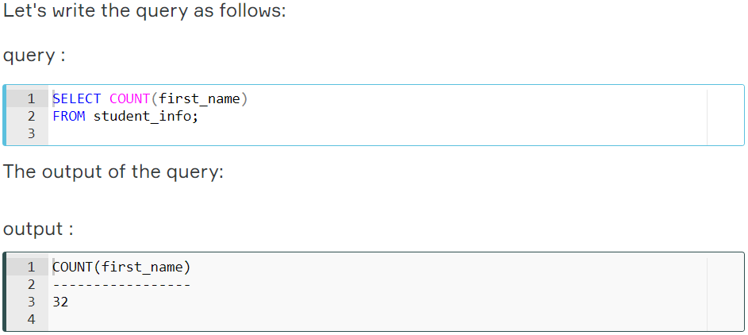

32 students enrolled in the courses.   
This query counts all the first names in the student_info table. You would reach the same result if you used COUNT(last_name). There is another special character returning the number of rows in a table. That is * character.  Use it inside the COUNT function as COUNT(*).   
  
If you notice that the header of the output query is displayed as COUNT(first_name). However, we can customize the header using AS keyword. AS is used to rename a column or table with an alias. This is the syntax:  
 SELECT column_name AS alias_name  
  
Let's rewrite the query above:

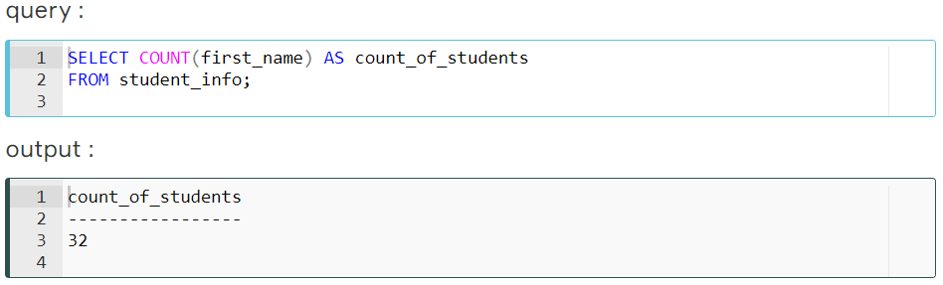

As you see that what you wrote after AS keyword is displayed as a column header.   
  
An important point for COUNT(*) function is that the result table includes NULL and duplicate values. If you want the number of non-null values, use the syntax COUNT(column_name).

### COUNT DISTINCT

In some cases, we may want unique values. For instance, let's find how many different fields there are in the student_info table.

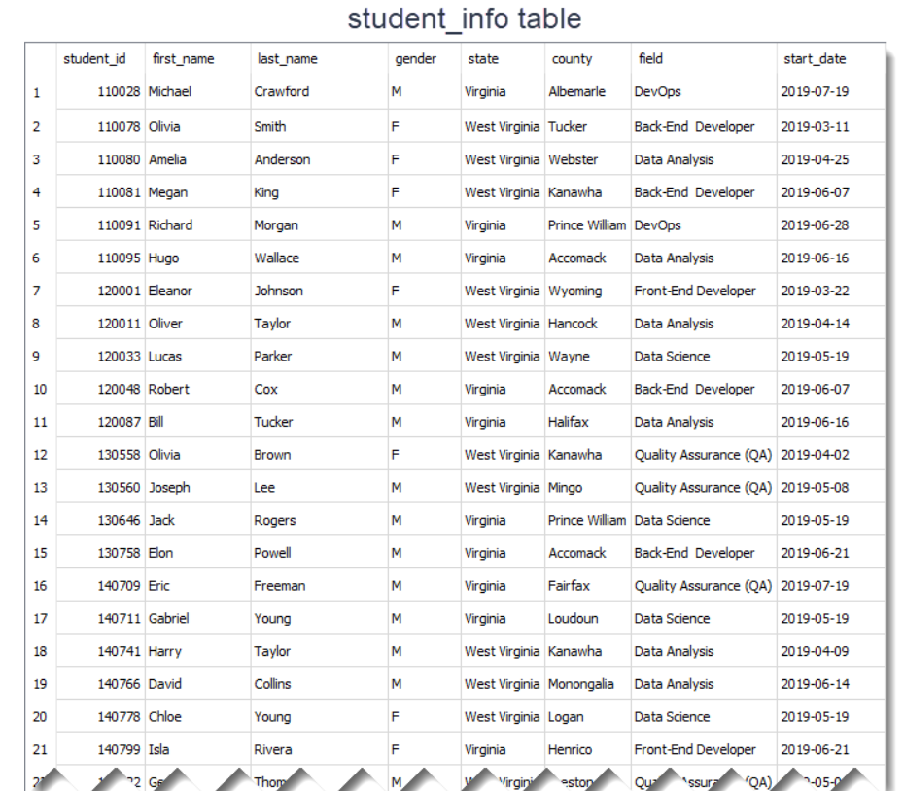

First, write this query:

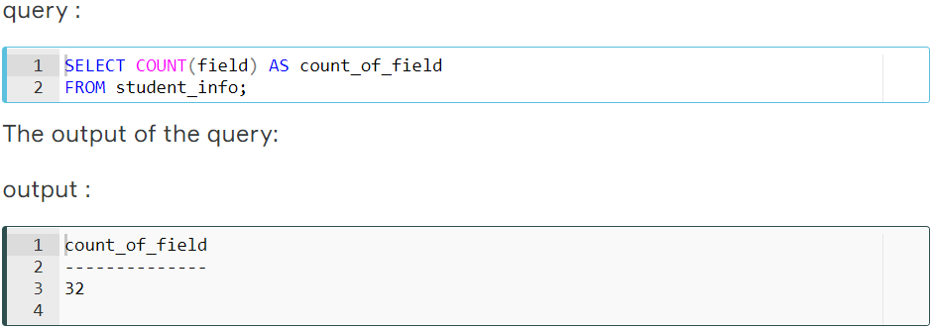

As you see that there are 32 fields. But, is that the correct number? Absolutely no. There are duplicate values. For instance, there is more than one student who enrolled in the course in the field of *Data Science*. COUNT(field) counts the duplicate rows as separate rows. So, we need to use COUNT(DISTINCT column_name) function here.

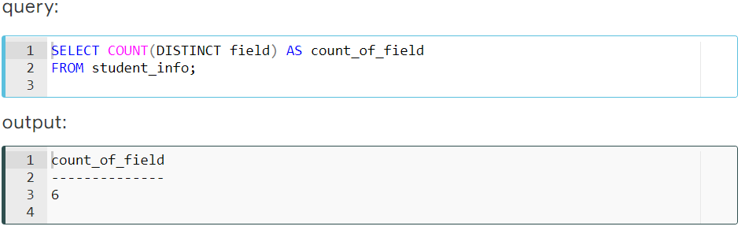

Actually there are 6 unique or distinct fields in which students may enroll. COUNT(DISTINCT field) returns the number of unique and non-null values in column *field*.

We can also combine COUNT(DISTINCT) or COUNT() functions with WHERE clause.

For instance, display the number of students from Virginia.

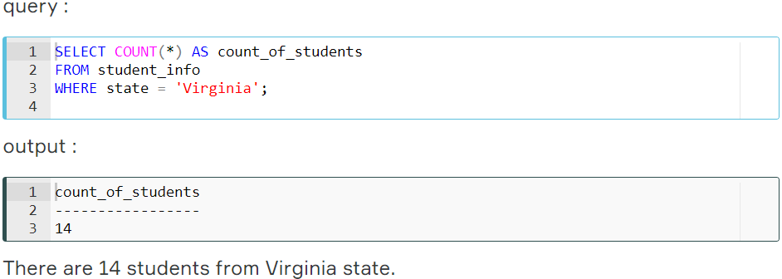

## MIN and MAX

### MIN Function

MIN function returns the minimum value in the selected column.

The syntax of the MIN function:



The MIN function ignores the NULL values. Thus, it retrieves the non-NULL minimum value in the selected column.

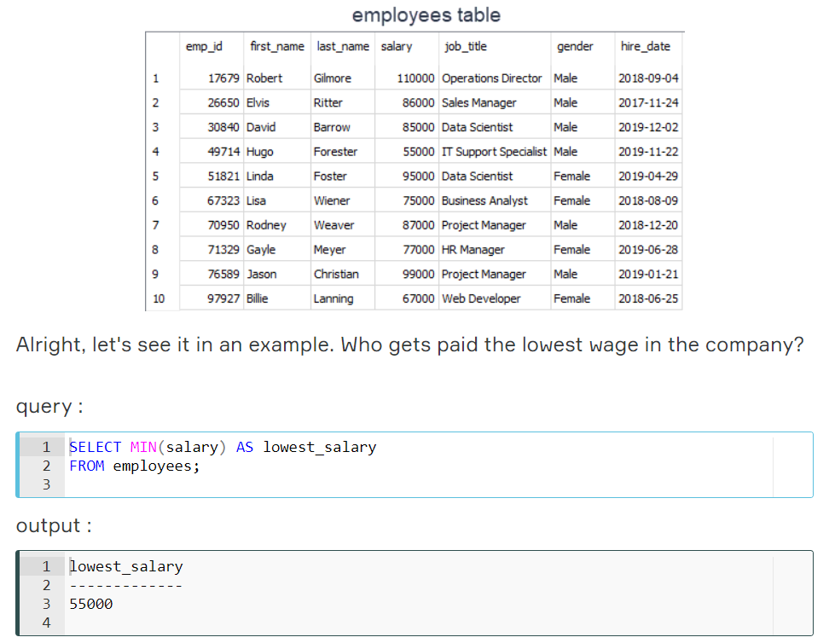

We can also combine MIN function with WHERE clause. Let's move the query above to the next level. Display the female employee who gets paid the lowest.

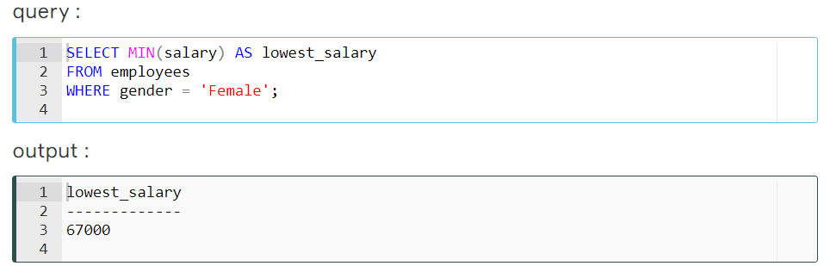

You can use ORDER BY and LIMIT keywords to get the minimum value in a selected column. This will yield the same result as in the MIN function.  
  
The MIN function can also be used with dates. For instance, display the earliest hired employee's date.

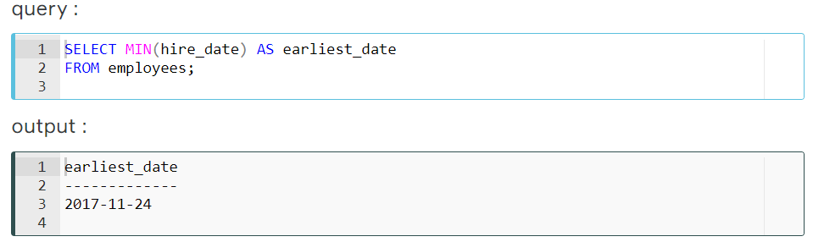

### MAX Function

MAX function returns the maximum value in the selected column. With the MAX function, you can find the highest salary among the employees, the most expensive products, the longest track, etc.

The syntax of the MAX function:



The MAX function ignores the NULL values.

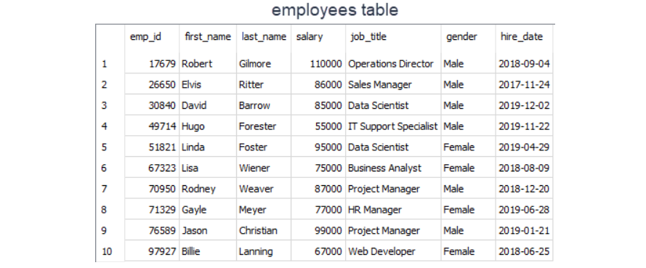

Alright, let's take the same example in the previous part. But, this time find the highest wage in the company.

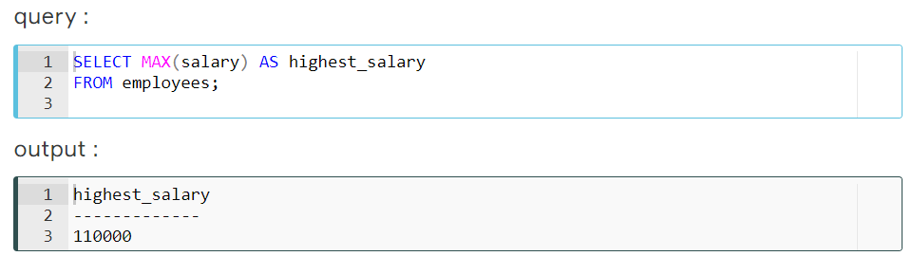

We can also combine MAX function with WHERE clause as we did in the MIN function. Display the male employee who gets paid the highest.

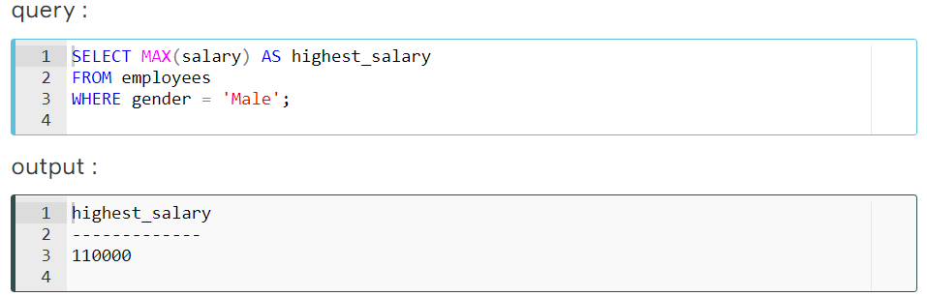

You can use ORDER BY and LIMIT keywords to get the maximum value in a selected column. This will yield the same result as in the MAX function.  
  
The MAX function can be used with dates. For instance, we can display the newest hired employee's date as below:

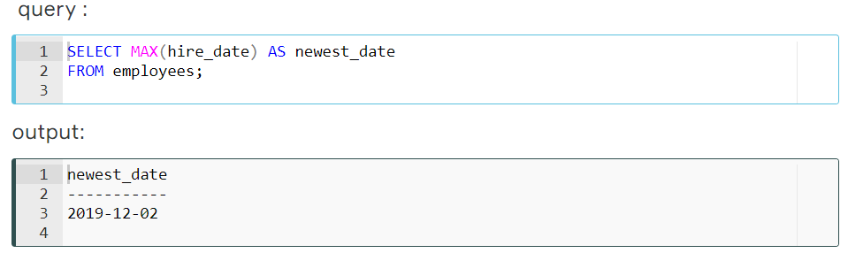

## SUM and AVG

### SUM Function

SUM function returns the sum of a numeric column.

The syntax of the SUM function:



Now, let's calculate the total amount of the salary of the employees in the company.

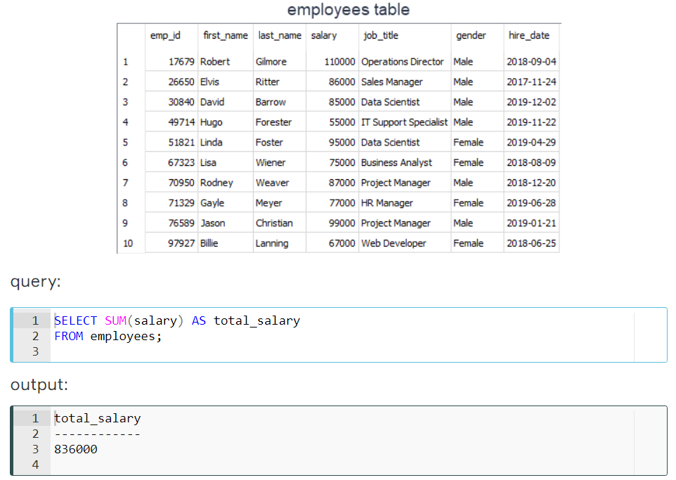

The amount of the total salary is $836,000. We can breakdown this into categories. For instance, we can find the total amount of salary of female employees.

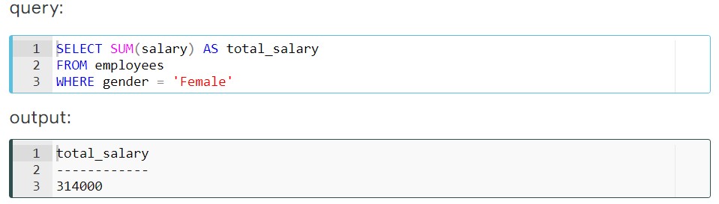

### AVG Function

AVG function calculates the average of a numeric column.

The syntax of the AVG function:



What is the average salary of the employees?

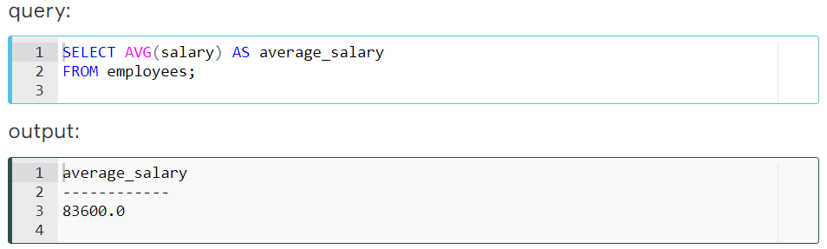

The average salary of the employees is $83,600.  The total amount of the salary is $836,000. Since there are 10 employees, the average salary is $836,000/10 = $83,600. We just proved it.  
  
Now, let's find the average salary amongst male employees.

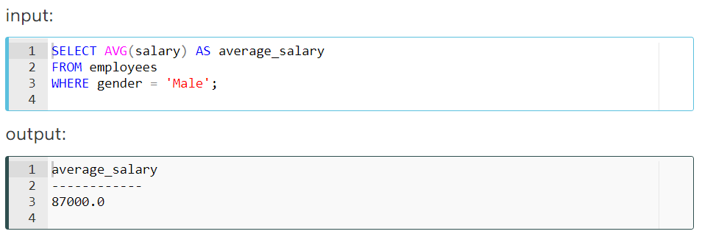

## Aggregating with Grouping

### GROUP BY Clause

There are some cases where we may need to apply the aggregate function not only to a selected group of rows. In the previous parts, we found the total amount of salaries of male and female employees separately.  What if want to show them in the same result table grouped by their gender. In such cases, we use GROUP BY statement.

Toplama işlevini yalnızca seçili satır grubuna uygulamak zorunda kalmayacağımız bazı durumlar vardır. Önceki bölümlerde, kadın ve erkek çalışanların toplam maaş miktarını ayrı ayrı bulduk. Bunları cinsiyetlerine göre gruplandırılmış aynı sonuç tablosunda göstermek isterseniz ne olur? Bu gibi durumlarda GROUP BY deyimini kullanırız.

The GROUP BY clause groups the rows into summary rows. It returns one value for each group and is typically used with aggregate functions (COUNT, MAX, MIN, SUM, AVG).

GROUP BY deyimi satırları özet satırlar halinde gruplandırır. Her grup için bir değer döndürür ve genellikle toplama işlevleriyle (COUNT, MAX, MIN, SUM, AVG) kullanılır.

The syntax is:

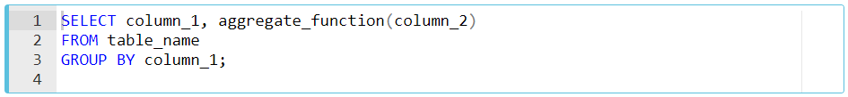

In case a WHERE clause is used, the GROUP BY clause should come after the WHERE clause. We specify the column or a list of comma-separated columns right after the GROUP BY.  Any nonaggregate expression in the SELECT must be included in the GROUP BY clause.

WHERE yan tümcesi kullanılması durumunda, GROUP BY yan tümcesi WHERE yan tümcesinden sonra gelmelidir. GROUP BY öğesinden hemen sonra sütunu veya virgülle ayrılmış sütunların listesini belirtiriz. SELECT içindeki tüm birleştirilmiş olmayan ifadeler GROUP BY deyimine dahil edilmelidir.

We've mentioned that the GROUP BY clause is often used with aggregate functions. Now, let's see how it is.

**💡Tips:**

* GROUP BY returns only one result per group of data.
* GROUP BY Clause always follows the WHERE Clause.
* GROUP BY Clause always precedes the ORDER BY.

### GROUP BY with COUNT Function

### 

### ☝ Important: The GROUP BY clause groups results before calling the aggregate function. This allows you to apply aggregate function to groups than the entire query. GROUP BY deyimi toplama işlevini çağırmadan önce sonuçları gruplar. Bu, gruplara sorgunun tamamından daha büyük toplama işlevi uygulamanızı sağlar.

### Now, let's write another query. What is the number of employees working as a data scientist? Break down it by gender.

### 

**💡Tips:**

* WHERE clause operates on the data before the aggregation. WHERE deyimi, toplama işleminden önce veriler üzerinde çalışır.
* WHERE clause happens before the GROUP BY clause. WHERE deyimi GROUP BY deyiminden önce olur.
* Only the rows that meet the conditions in the WHERE clause are grouped. Yalnızca WHERE yan tümcesindeki koşulları karşılayan satırlar gruplandırılır.

### GROUP BY with MIN&MAX Functions

Let's find the minimum salaries of each gender group using the MIN function.

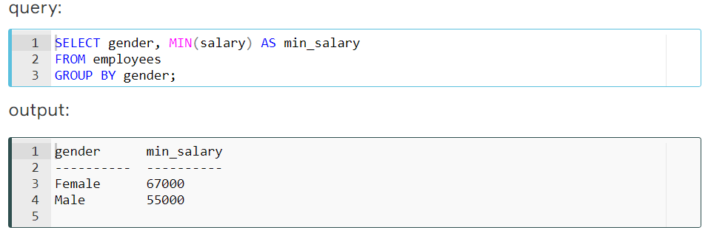

Similarly, we can find the maximum salaries of each group using the MAX function.

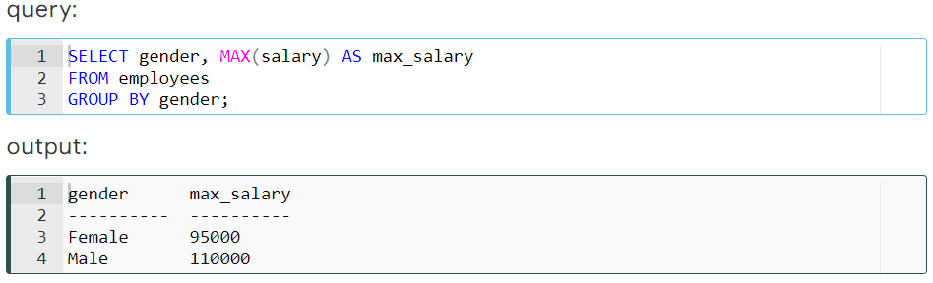

You may also use the ORDER BY clause to sort the salaries in descending or ascending order.  The ORDER BY follows GROUP BY. For instance, sort the maximum salaries for each group in descending order.

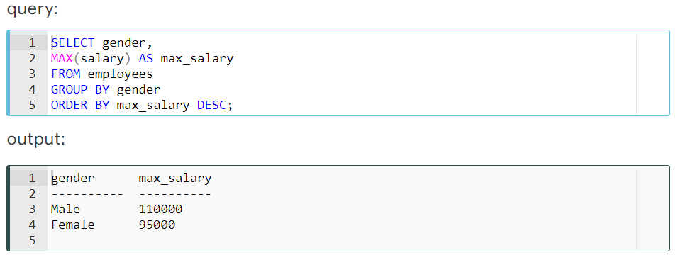

**💡 Tip:** When sorting, you can use the alias with ORDER BY clause as we did in the query above (ORDER BY **max_salary**). You may also use the original aggregate function as ORDER BY **MAX(salary**)

### GROUP BY with SUM&AVG Functions

In the previous part, we have learned how to use MIN and MAX functions with the GROUP BY clause. In this part, we will continue with SUM and AVG functions. Let's go with the same scenario. In this case, we will calculate the total salaries of each group (gender).

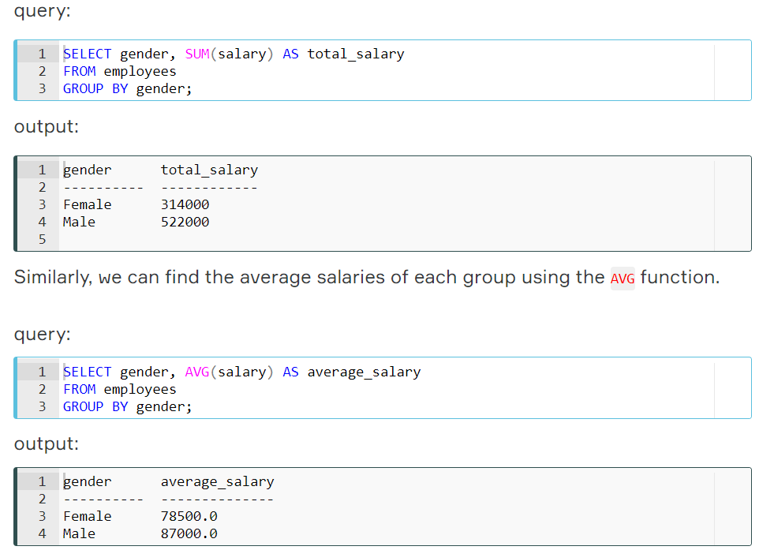

You may also use the ORDER BY clause to sort the salaries in descending or ascending order. For instance, sort the total salaries for each group in descending order.

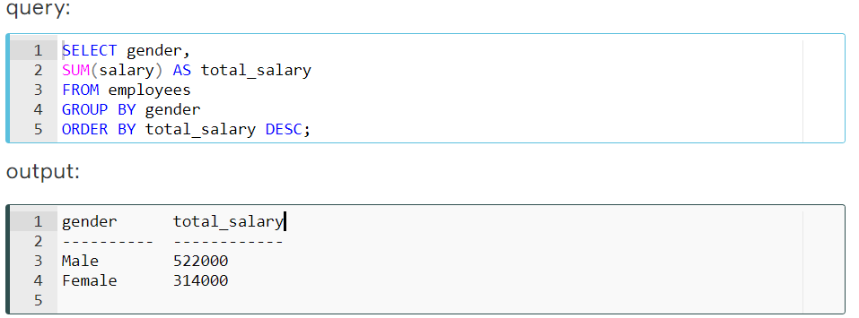

What is JOIN?

Introduction

In this section, we will introduce you to *JOIN clauses*. A JOIN clause is used to combine two or more tables into a single table. Joins are usually applied based on the keys that define the relationship between those tables or on common fields.

**💡Tips:**

* In most cases this joins are created using the primary key of one table and the foreign key of the table we want to join it with.
* Çoğu durumda bu birleşimler bir tablonun birincil anahtarı ve ona katılmak istediğimiz tablonun yabancı anahtarı kullanılarak oluşturulur.

We've added a new table "departments" to our company database. We have now two tables "employees" and "departments" in the database. Now let's examine those two tables. In the "departments" table, the names of the employees are not written, only the ID numbers of the employees are written.

Let's look at the "employees" table:

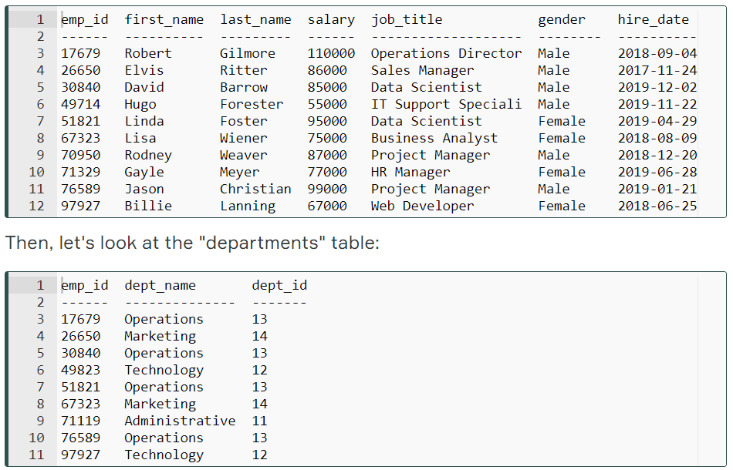

When looking at the "departments" table, it is not easy to understand which employee is working in which department, since this table does not contain the names of the employees. For this purpose, two tables should be combined and the name and surname of that employee should be found by looking at the "employees" table for each employee ID in the "departments" table. The "emp_id" is the column that will form the relationship between the two tables above.

"Bölümler" tablosuna bakıldığında, hangi çalışanın hangi departmanda çalıştığını anlamak kolay değildir, çünkü bu tablo çalışanların adlarını içermemektedir. Bu amaçla, iki tablo birleştirilmeli ve "departmanlar" tablosundaki her çalışan kimliği için "çalışanlar" tablosuna bakarak bu çalışanın adı ve soyadı bulunmalıdır. "Emp_id", yukarıdaki iki tablo arasındaki ilişkiyi oluşturacak sütundur.

### JOIN Types

There are basically five types of JOINs: INNER JOIN, LEFT JOIN, RIGHT JOIN, FULL OUTER JOIN and CROSS JOIN. As a special case, a table can join to itself and this type is called SELF JOIN.

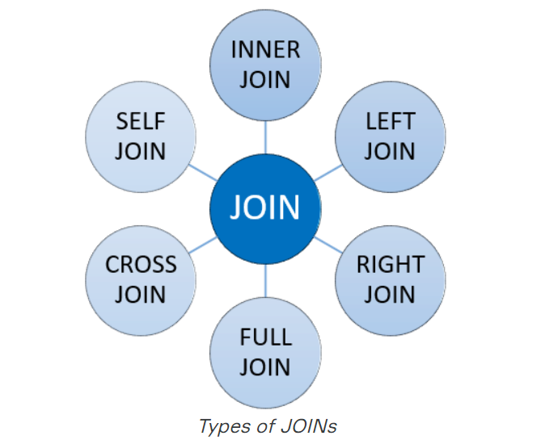

Let's make a brief description of JOIN types without going in-depth:

* **INNER JOIN:** Returns the common records in both tables. Her iki tabloda da ortak kayıtları döndürür.
* **LEFT JOIN:** Returns all records from the left table and matching records from the right table. Sol tablodaki tüm kayıtları ve sağ tablodaki eşleşen kayıtları döndürür.
* **RIGHT JOIN:** Returns all records from the right table and matching records from the left table. Sağ tablodaki tüm kayıtları ve sol tablodaki eşleşen kayıtları döndürür.
* **FULL OUTER JOIN:** Returns all records of both left and right tables. Hem sol hem de sağ tabloların tüm kayıtlarını döndürür.
* **CROSS JOIN:** Returns the Cartesian product of records in joined tables. Birleştirilmiş tablolardaki kayıtların Kartezyen ürününü döndürür.
* **SELF JOIN:** A join of a table to itself. Masanın kendi kendine birleşmesi.

In our course, we'll focus on INNER join and LEFT join which are commonly used.

Q: What is a Join?  
A: The SQL Join clause is used to combine records (rows) from two or more tables in a SQL database based on a related column between the two.

## Inner JOIN

### Introduction

INNER JOIN is the most common type of JOINs. It creates a new result table based on the values in common columns from two or more tables. INNER JOIN returns a table that contains only matched rows that meet the specified join conditions.

Here is the syntax of the INNER JOIN clause:



In this syntax,

* *columns*: Column names from *table_A* or *table_B.*
* *table_A, table_B*: The names of the joined tables.
* *join_conditions:* It specifies the conditions to evaluate for each pair of joined rows.

A join condition generally takes the following form: table_A.column = table_B.column. The operator in this statement is usually an equal sign (=), but any comparison operator can also be used.

**💡Tips:**

* Note the ON keyword for specifying the INNER JOIN condition.
* Multiple join conditions can be written using AND or OR statements.

In addition, three or more tables can be combined using the INNER JOIN clause. The syntax used to join three or more tables is as follows:

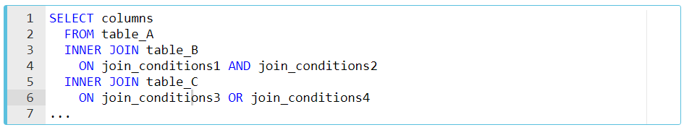

Q: What is inner join?  
A: Retrieves records that have matching values in both tables involved in the join. This is the widely used join for queries. Birleştirmede yer alan her iki tabloda da eşleşen değerlere sahip kayıtları alır. Bu, sorgular için yaygın olarak kullanılan birleştirmedir.

### Example

Suppose you want to join the "employees" table and the "departments" table. In this example, an INNER JOIN has been created that is based on the *emp_id*columns in the two tables:

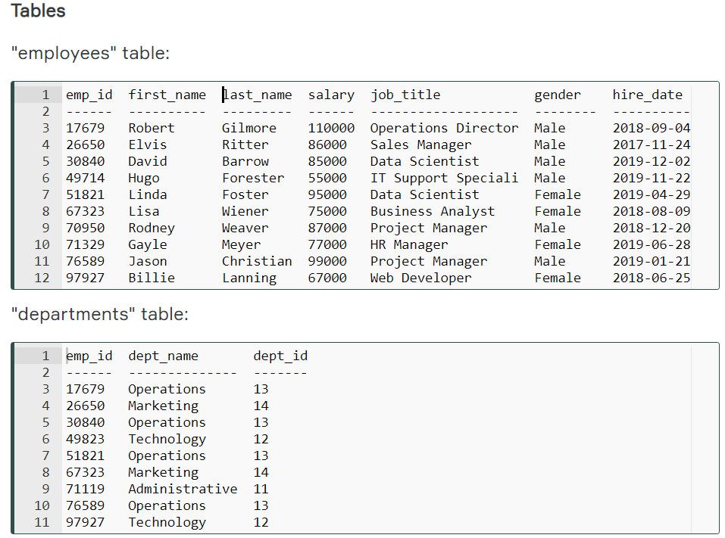

To understand easily how INNER JOIN works, we can use the following visual explanation. The intersection of the two tables represents the matching rows.

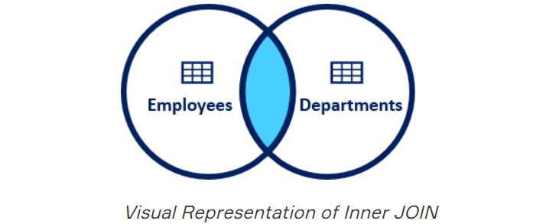

**Syntax**

The INNER JOIN keyword selects all rows from both "employees" and "departments" tables as long as there is a match between the columns. If there are records in the "employees" table that do not have matches in "departments", these records are not shown in the output.

INNER JOIN anahtar sözcüğü, sütunlar arasında bir eşleşme olduğu sürece hem "çalışanlar" hem de "departmanlar" tablolarındaki tüm satırları seçer. "Çalışanlar" tablosunda "departmanlarda" eşleşmesi olmayan kayıtlar varsa, bu kayıtlar çıktıda gösterilmez.

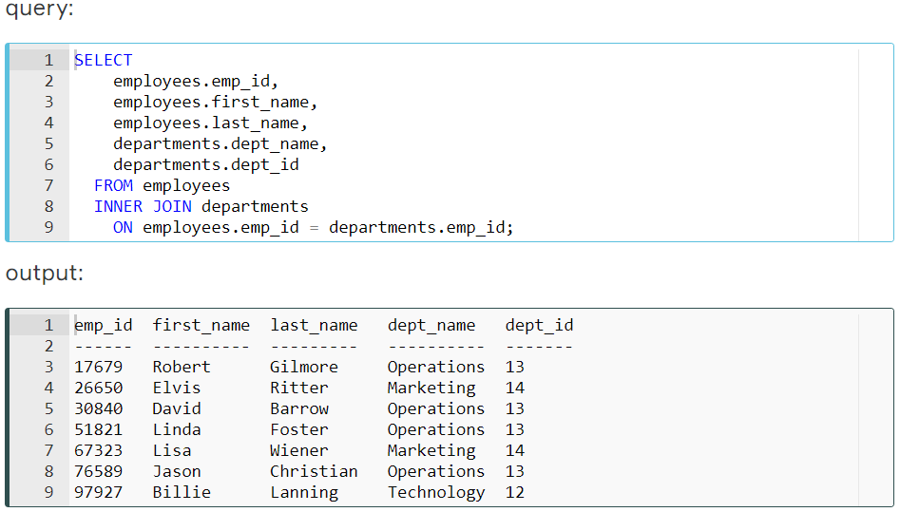

As you can see from the output, the seven employees in the "employees" table have matches in the "department" table. The remaining three employees are not listed in the output. As you can see, employee ID 17679 is in both tables and matches, so it is included in our output table. On the other hand, employee ID 49714 is included in the employee table but not in the department table and there is no match. Therefore, employee ID 49714 is not included in the output table.

## Left JOIN

### Introduction

In this JOIN statement, all the records of the left table and the common records of the right table are returned in the query. If no matching rows are found in the right table during the JOIN operation, these values are assigned as NULL.

Here is the syntax of the LEFT JOIN clause:



In this syntax,

* *columns*: Column names from *table_A* or *table_B.*
* *table_A, table_B*: The names of the joined tables.
* *join_conditions:* It specifies the conditions to evaluate for each pair of joined rows.

LEFT JOIN and LEFT OUTER JOIN keywords are exactly the same. OUTER keyword is *optional*.

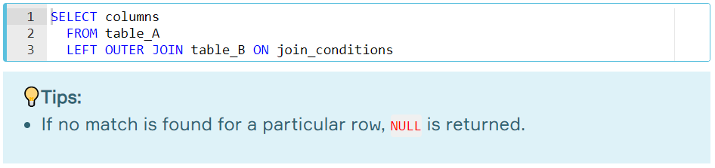

### Example

Suppose you want to join the "employees" table and the "departments" table. In this example, a LEFT JOIN has been created that is based on the *emp_id*columns in the two tables:

**Tables**

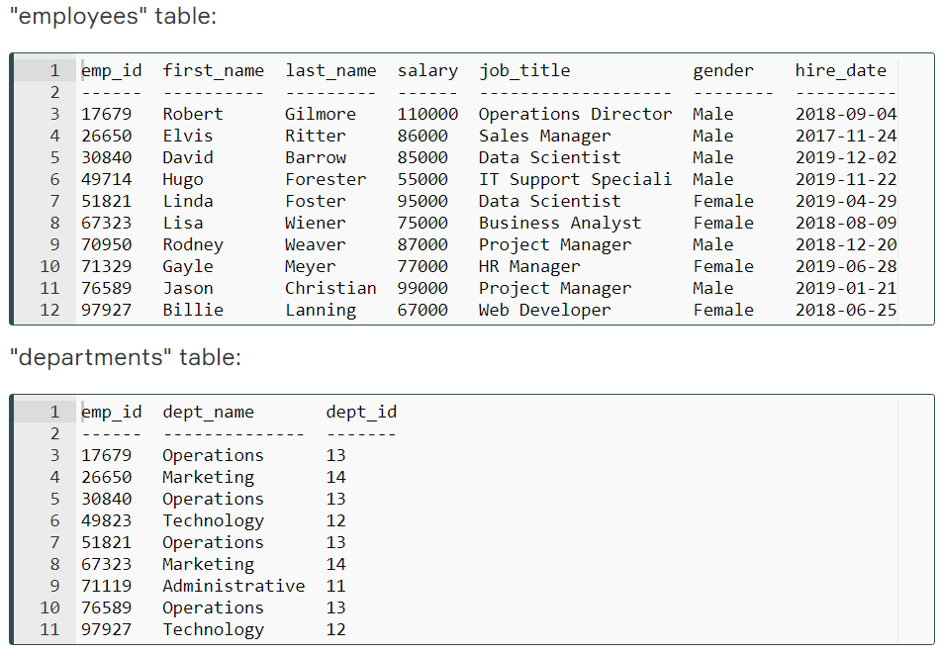

To understand easily how LEFT JOIN works, we can use the following visual explanation. The shaded area represents all rows in the "employees" table and all matching rows in the "departments" table.

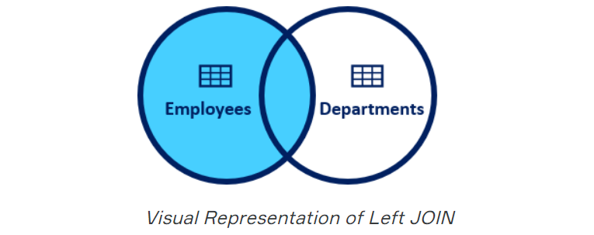

**Syntax**

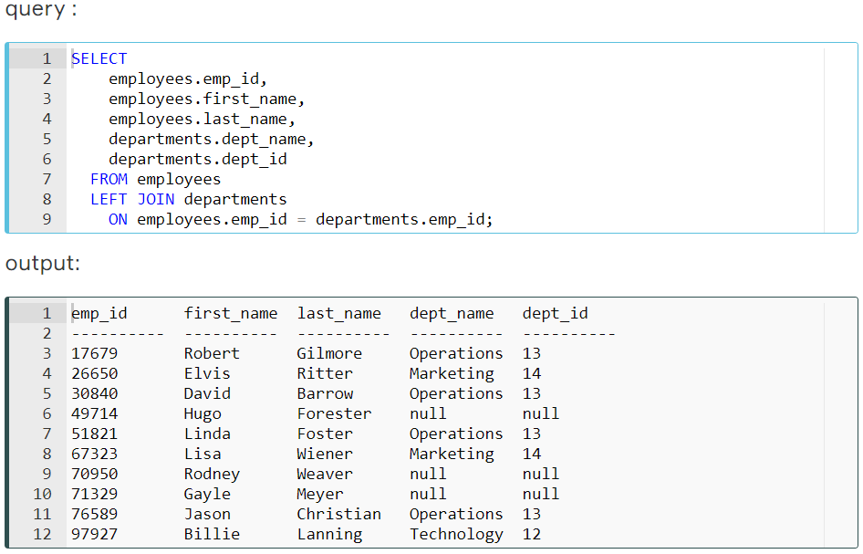

As a result of the LEFT JOIN operation, all ten rows are returned from the "employees" table and all matching rows in the "departments" table are returned. The rows that do not match with the right table are returned as null.